Decomposing a Composition: On the Multi-layered Analysis of Expressive Music Performance.
Esther Coorevits¹, Dirk Moelants¹, Stefan Östersjö², David Gorton³, Marc Leman¹
¹ IPEM, Dept. Of Musicology, Ghent University
esther.coorevits@ugent.be
² Orpheus Institute, Ghent
³ Royal Academy of Music, University of London
Abstract. In our engagement with music, not only the physical experience of sound is important. Also the interplay between body movements, musical gestures and the cognitive processes of performers and listeners is part of our experience. Yet, this multimodal aspect is not always fully considered when analyzing music performance. In this paper, we want to establish a framework for a multi-layered analysis of music performance, building on data retrieved from quantitative and qualitative procedures and involving the perspectives of composer, performer and musicologist. The performance of a classical guitarist was analyzed in detail, using both a ‘bottom-up’ approach (audio-analysis and motion-capture) and a ‘top-down’ perspective (annotations from video-footage, perceived phrasing and the composer’s, performer’s and researcher’s perspective). These different analytical layers were compared and evaluated, which pointed out that multiple perspectives can reinforce each other in understanding musical intentions and can help detecting mismatches between qualitative and quantitative data. The analytical framework developed could be an important step in the coupling of performer’s intentions with the expressive enactment of a musical score.
Keywords: Music Performance. Gesture. Multimodal analysis. Embodied Music Cognition.
- Introduction
Music performance is often described as a multimodal experience, both for the performer and the audience [1]. From an ecological point of view [2], our engagement with music, as listener or performer, is a process of perceiving what is happening around us and trying to understand, and adapt to, what is going on [3]. In other words, we are involved in sense-giving activities that take place in a multimodal environment. Auditory stimuli form an important part of that environment, but human perception engages all senses, and involves next to sound also vision, smell, touch, taste, sense of movement, emotion, bodily sensations and so on.
Consequently, music as a phenomenon is more than a physical experience of sound waves in the air. According to the Embodied Music Cognition theory [4], we perceive music by means of our body, which acts as a mediator between the external environment and our subjective sensations and experiences. Interaction with the environment, for example, would typically comprise inverse and forward prediction components [5], meaning that we can predict the subjective sensations we will perceive from certain actions in the physical world (forward modeling) but also that we will associate our immediate, personal sensations with a certain action (inverse modeling). Thus, action and perception prediction models are linked with sensorimotor and body-related articulations, resulting in what is called an action-oriented ontology [4] or the coupling of actions with their consequent outcome or goal. This repertoire of goal-directed actions or gestures can be considered as a collection of movements made to achieve a particular goal, linked with the experiences and sensations resulting from such actions.
The repertoire of gestures provides a basis for the enactment of music, both in music performance and in music listening. The coupling of actions and perceived sensations forms a mechanism that guides our understanding of music, which makes these gestures a vehicle for the construction of musical meaning. Musical gestures are inherent to music performance, and skilled musicians will be able to convey musical expression by means of their body movements [6,7,8]. High-skilled performers can encode their musical intentions or goals into ‘moving sonic forms’, which involves both mental processing and corporeal control over a musical instrument [4]. These musical intentions can be related to an overall stylistic target (general style of the piece) as well as intended expressive sensitivities at a local structural level [9], [6]. According to Godøy [10], these locally intended targets will guide the performer’s grouping or co-articulating of smaller movements into gestures. As such, these local targets can be understood as a reference frame, which guides the musician’s construction and shaping of a musical piece. In that sense, the musician is part of the creative process and establishes a relationship between notation, action and sound [11].
Given this framework, music performance can be seen as constructed out of different layers of significance and can therefore be described from different levels. Low-level or bottom-up descriptors such as physical characteristics of sound (i.e. timing, intensity,…) and movement (Quantity of Motion, kinematics,...) and high-level features (emotions, subjective experiences, verbal descriptions) accessed from a top-down approach, are both related with the musical material (score) [12,13,14]. All these different layers are connected in a sense to musical expression [15].
In this study, we want to access and explore the different levels of expressiveness in a performance and try to establish a relationship between these layers of analysis. By deconstructing a musical performance in different layers, the complexity of music as a multimodal experience can be reduced without losing the richness of impressions inherent in such an experience. The purpose was to develop a methodology that can provide a framework for further in-depth analysis of other performances in the future that takes into account the interplay between the different modalities inherent to music and the different actors involved, being the composer, performer and musicologist. This way, an attempt could be made to access expressiveness in music from the performer and observer’s perspective [4].
- Methods
  - Music
In this study, we consider a performance of “Austerity Measures I”, a piece by the British composer David Gorton for ten-string guitar (Fig. 1). The piece consists of 64 bars of music, which can be divided in 5 sections in which different types of material are used. The first part (bars 1-15) consists of relatively isolated chords using harmonics on the guitar; the second part (bars 16-30) continues to use harmonics, but now presented as series of single notes mostly with large pitch intervals. The third part (bars 31-49) consists of a series of ascending melodies with 5-12 elements, played in a more ‘lyrical’ legato style. The fourth part (bars 50-58) is a series of 10-note arpeggio patterns and the fifth part (bars 59-64) is a kind of coda, stylistically reflective of part 3, but containing just one ascending pattern with gradually decreasing dynamics. However, it may be argued that this sequence of scored material is not ‘the work’ but rather material which is activated in performance according to rules that instruct the performer to ‘decompose’ the scored material.
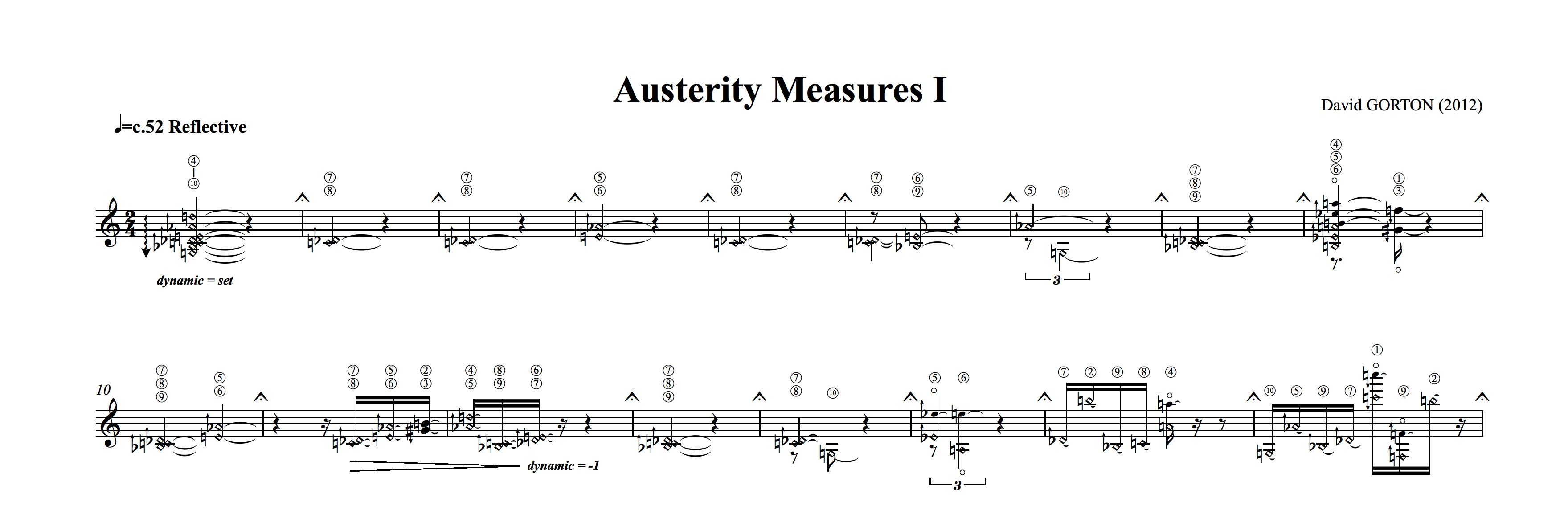
During performance, the score should be repeated three or four times. When playing through four times, the performer labels each bar with the numbers 1, 2, 3 or 4, with a roughly equal distribution and frequently changing the order of the numbers throughout the piece. Only the first and the last bar have a fixed label, which is 4. In the first round, the piece should be played as it is written, but for the second run-through, all bars labeled 1 should be replaced with rests. On the third time, all the bars labeled 1 and 2 should be replaced with rests, and on the fourth time, all the bars labeled 1, 2, and 3 should be replaced with rests, leaving the performer only those bars labeled 4 to play. In other words: during the performance, the piece is constructed by deconstructing it. When playing through three times, the process is similar, using the numbers 1 to 3 instead of 1 to 4.
Fig. 1. First 17 bars from the score of “Austerity Measures I”.
The instructions for the piece establish a rudimentary economic system, which governs the allocation of musical resources to the guitar player. While, through the numbering of the bars, the performer has control over which materials are cut, and at what stage in the piece they are cut, the implications of the cuts are difficult to envisage from the patterns of the numbers, and are only fully realised through the literal ‘playing-out’ of the system. When Austerity Measures I is created live on stage, the performer is forced to re-evaluate the surviving materials within their new contexts with each play-through and therefore, the expressive outcome in terms of timing, performance dynamics and bodily gestures are emergent from the immediate context. Phrases that span several bars become broken and fractured, requiring new phrasing and shapes to be sought by the performer. Musical material that was originally separate and distant, become adjacent gestures, connected by silence. Increasingly lengthy silences encroach upon the flow of the surviving materials, requiring preparation and framing. The tempo of the piece is flexible in order to leave space for the performer to phrase and shape the music to his expressive intentions. The loss of material during the piece forces the performer to rethink the musical material and adjust its musical ideas and goals, but the process should not be understood as automatic. The choice of which bars to keep and which ones to leave out influences the performer’s priorities and structural notions of how to shape the music. Hence, the local musical targets that serve as a reference frame change, which will affect the musician’s construction and shaping of the performance.
  - Procedure
Concert and rehearsal performances of both the four and three times run-through of the piece by the Swedish guitarist Stefan Östersjö were recorded at the Orpheus institute in Ghent, during the Orpheus Research festival on 1-3 October 2014. The four-times rehearsal and concert performance were recorded on the first day, in a concert auditorium and with a seated audience in the concert performance, while the three times rehearsal and concert were recorded in the central hall of the institute with a standing audience in the concert performance. The set-up of the recordings had to be flexible in order to move it to different locations and without interfering too much with the natural setting of the concert (the communication between musician and audience) to ensure ecological validity. This has important consequences for the technology used.
For both the rehearsal and concert performance of the two versions of the piece, audio, video and movement recordings were made. A contact microphone was used to record a dry guitar signal for analytical purposes, while a condenser microphone recorded the guitar sound with the ambience of the room. Two types of movement data were extracted from the performance: 4 sensors attached under the surface on which the guitar player was seated measured the executed pressure and displacement of weight. Active infrared markers were attached to the head, shoulders and right wrist and registered with two Wii-motes placed in front of the performer.
The amount of infrared markers that could be registered was limited to 4, so the body parts had to be chosen deliberately and in agreement with the performer. All data streams were synchronized using Max/MSP/Jitter[16] and OSCulator [17] and both the pressure sensors and the Wii-mote data were sampled at 100 Hz. In addition, the complete performance was recorded on video with a sample rate of 50 Hz.
- Analysis
In this paper we mainly want to establish a suited methodology, therefore only the first concert performance (4 run-throughs) was taken into consideration. The main goal of the analysis was to extract expressive details to detect consistent and changing performance strategies. First, we give the details of the separate layers of analysis, followed by the method to combine these approaches.
  - Timing
Onset-time bars. The time structure of the piece was analyzed at the level of the bar. It is the main structural unit in the piece, as the units that are removed and replaced with silences are always bars. The start of each performed bar was manually annotated using praat [18], a program that gives an analysis of dynamics and pitch together with the sound wave and a spectrogram of the sound. This analysis gives us a precise view on how the global time structure evolves through the successive run-throughs of the piece. The analysis at the bar level forms the basis for an analysis at larger structural levels, such as the different run-throughs and the five sections mentioned in 2.1.
Perceived phrasing. Perceived phrasing across the performances was reached through a process of negotiation between composer, performer and musicologists. By listening together to the recordings, the participants discussed and agreed upon a combined understanding of the shaping and phrasing of materials. While material within an individual bar was always considered an independent unit, the negotiation identified the perceived joining together of bars into phrases, and the perceived combination of these phrases into super-phrases. A new score was then compiled, which replaces with rests those bars that Stefan cut out in each run-through, and annotates the agreed phrasing structure using dashed slurs for the phrases, and dotted slurs for the super-phrases.

  - Video analysis
To analyze the video recordings, a method consisting of several steps was applied building on a basic procedure referred to as ‘stimulated recall’ [19]. The goal was to detect expressive movements in the performance that were not immediately related to technical (or sound-producing [20]) gestures. Performer, composer and two musicologists first watched the video of the performance together, using the software Hyper Research (HR) [21]. At any moment one of them marked an event they perceived as ‘expressive’, the video was stopped. To give the event a name (code), the four persons involved in the analysis negotiated about the meaning of this event, based on how they personally perceived it. If consensus was reached, the code was added to the video and annotated in HR. During this first phase not only some basic codes were introduced, but more important, a common frame of reference was agreed between the participants, which was crucial for the next stage.
In this next stage, the persons involved in the analysis watched the performance alone and coded the videos individually in order to obtain a rich list of codes, involving the different viewpoints of composer, performer and researcher. In a second session of common coding, the code lists from the individual coding were discussed. Overlaps of codes were deleted, meaning that different code names for the same expressive event were set equal (e.g., ‘accentuating head movement’ and ‘head beats’ were renamed as ‘nodding’). Also, some specific codes were assigned to a more general code, like ‘worried’ and ‘angry’ which were assigned to ‘facial expression’. In the end, a list of 18 codes for which the four parties agreed on the meaning was fixed and used for the second part of the video analysis. Here, the performer and one of the musicologists individually annotated the four recordings in HR using the new code list. Each time an expressive event occurred that matched a code in the list, this code was added to the video.
This resulted in two parallel annotations, which were discussed in a final common session. Here, all coded events for which in the end no consensus was reached were deleted from the annotations. The final result of the video analysis was one annotated file per recording, containing a list of 18 different codes, which were applied to all expressive events in the video where the four parties found an agreement on. The different steps of common and individual coding, involving the composer, performer and external observers, ensured that the result was a reliable annotation of a performance in terms of high-level descriptors.
  - Movement Data
Wii-data. From the infrared markers, relative X- and Y-coordinates shoulders and right wrist could be extracted. Due to light conditions in the concert hall, the data from the head markers could not be used. X- and Y-coordinates were normalized to values from -1 to +1. From this signal, kinematic variables (velocity & acceleration) were calculated and the resulting data was smoothed using a first order Savitzky-Golay filter as outlined in the MoCap Toolbox [22].

Pressure sensors. For each sample, the Cartesian coordinates of the point of gravity of the performer were derived from the 4 pressure sensors (1) (Fig. 2). For this point, polar coordinates (vector length & angle) were calculated and the result was smoothed using a local weighted regression filter with a polynomial order of 2 (Loess-filtering).
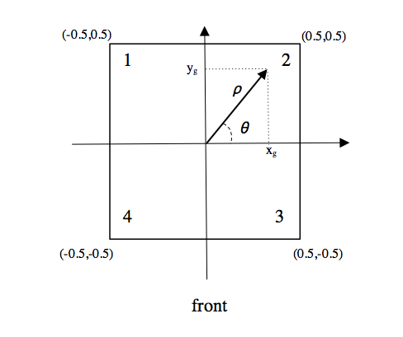
Fig. 2. Representation of the surface with pressure sensors (1 2 3 4). Let W be the sum of w₁, w₂, w₃, w₄ (the fractional weights of each sensor). The position of the point of gravity of the 4 sensors is then defined as in (1). The (x_{g},y_{g}) coordinates are then converted to polar coordinates (θ, ρ). ρ is the length of the vector and is a measure of the intensity of movement.
x_{g} = -(w₁+w₄)/W + 0.5 = (w₂+w₃)/W – 0.5 (1)
y_{g} = -(w₃ + w₄)/W + 0.5 = (w₁ + w₂)/W – 0.5
From these polar coordinates, the movement of the point of gravity was derived (norm of the vector), resulting in a measure for Quantity of Motion (QoM).
  - Multi-modal analysis
Figure 3 gives an overview of the different layers of analysis. In order to align the different layers, the musical score was used as an overarching framework. A global evolution of timing, movement data and detected gestures throughout the run-throughs of the piece was used as a guideline to detect general performance strategies. The next step was to compare the different sections within the score over each run-through and in the end, to use the annotated gestures from the video as a reference point for analyzing the movement data.
Fig. 3. Overview of the different layers of analysis over the full performance: movement data (wrist, left & right shoulder, displacement of weight) and annotated gestures (blue lines).
Bottom-up approach. The timing analysis and processing of the movement data are considered as bottom-up strategies to analyze the musical performance. The data provides ‘objective’ measurements of expressiveness in the performance as no semantic interpretation of the data is given.
The timing of bars, sections and run-throughs give us an objective representation of the temporal structure of the performance. It allows us to see how the timing deviates from a strictly isochronic rendering of the score and how the process of compression influences the timing over the different run-throughs. Based on the annotations of sections and bars, the mean QoM was calculated within these different fragments by summing the QoM at each timing instance (as calculated in 3.3) and dividing it by the total duration of the fragment. The velocity derived from the positional data of the Wii gives an indication of the kinetic energy of the measured body parts (E_{k} = 1/2mv², following Dempster’s human body model [23]). In order to detect specific performance cues, mean velocity and acceleration over the annotated sections, phrases and bars were calculated in a similar way as the QoM.

Top-down approach. The perceived phrasing and the list of annotated gestures from the video-analysis containing start, end and duration of each gesture, offers a top-down approach, as these are “subjective descriptors” of the performance.
The % of time and number of appearances of annotated gestures in the different run-throughs were compared using a chi-square test. The chi-square test tells us whether or not a distribution is equal between categories. This comparison allows us to detect where changing the musical material alters performance gestures and which gestures are used consistently. A gesture was considered ‘consistent’ when appearing at least in 3 of the 4 run-throughs. Also, the correlation of gesture-occurrence was tested as follows: the amount of time gesture (y) appeared during gesture (x), divided by the total time of gesture (x) (2)
T(g(x) = g(y)) / T(g(x)) (2)
In order to align this top-down approach with the results form the bottom-up analysis, the occurrence of the annotated performance gestures were also considered per bar. It is worth noting that the occurrence and duration of these gestures were not limited to the framework of the musical bar, but it allows an easy comparison between the different layers. When a gesture occurred over several bars, all the bars were judged as containing that particular gesture.
In a visual representation, the perceived phrasing could be compared with the annotated gestures in the score, and the timing structure as extracted from the onset-analysis. In the end, the performance targets that were detected using these different approaches were compared and evaluated. In the next section, this process will be explained in more detail.
- Results
  - Bottom-up analysis
Section-level. The timing analysis based on the durations of the bars gives us insight in the evolution of the performance through the 4 run-throughs. As each run-through means that a number of bars are replaced by silence, we see that the average distance between the start of two successive bars increases gradually (2.55-3.23-4.40-8.52 s). This process is illustrated in detail in Figure 4.
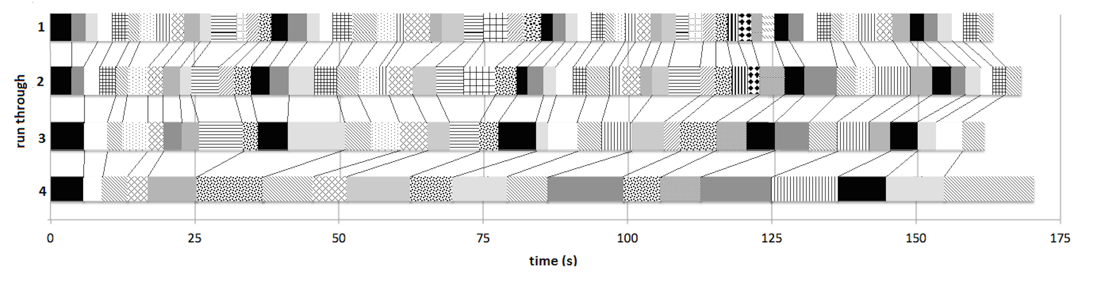
Fig. 4. Illustration of the deletion process in the performance of “Austerity Measures”. Each cell represents the duration from the start of a bar to the beginning of the next bar, the black cells indicate the first bar of a section. The four horizontal layers represent the four run-throughs, the black lines in between them show which bars are deleted and how the time-scale is contracted or extended.
This figure also shows that the evolution of the timing is not strictly linear: sometimes the sum of the bars is shorter, while in other cases the duration increases. We can now look at this at a higher structural level and compare the length of the five main sections (Fig. 5). The comparison shows that there is a clear change between the second and the third run-through only in the second section, which clearly becomes shorter. The only other striking difference is the lengthening of the final part in the last run-through. Obviously, this is related to the length of the final bar, which is extended to convey the end of the piece.
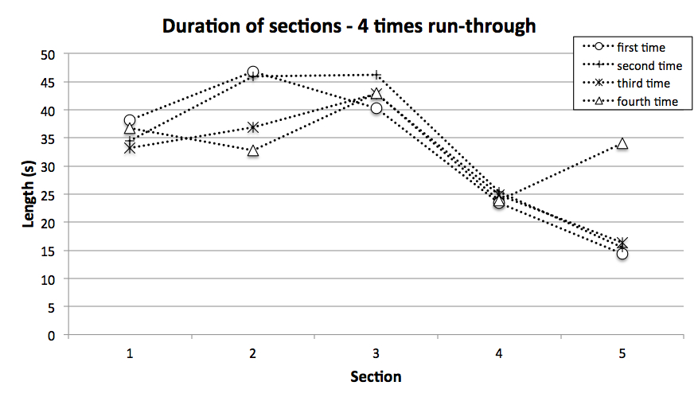
Fig. 5. Total duration (top) and QoM (bottom) for each of the five sections in the performance. The four lines represent the four run-throughs.
When comparing the shaping of musical time in the five sections of each run-through with the mean QoM of each section, a striking similarity can be observed (Fig 5). A similar relationship between the several sections is maintained in both the QoM and timing within the 4 run-throughs. In the first and second run-through, QoM and duration raise in the second section, to lower again in the third section. In the first run-through, both duration and QoM lower again, while in the second run-through, QoM rises to its highest point. Towards the last section, QoM and duration lower in both the first and second run-through. For the third run-through, the QoM reaches it lowest point in the second section and increases again towards the last section. This is in contrast with the shaping of time, as the duration seems to lower from the third section towards the end of the third run-through. In the last run-through, QoM and duration perfectly seems to mirror each other, similar to the first run-through.

Bar-level. Looking into more detail, the QoM within the bar was considered (Fig 6). This gives a better view on the musical material that is ‘lost’ over the different run-throughs. Based on consistency and change in QoM, possible musical targets can be detected: In each of the four run-throughs, peaks in QoM can be seen at bars 26 and 30-33 and a general downwards trend in the last part of the third section (ca. bars 42-51). In bar 59, QoM is also generally low. On the other hand, we see a change in the movement through the decomposition process. In bars 15-16 and 27-28 for example, the increase of movement observed in the first two run-throughs is lost in the third and fourth repeat. The first part of the second section (bars 17-25) seems to be the most stable region for all the four run-throughs. In general, the second run-through mirrors the first repeat, as the third and fourth run-through seem to be more similar. The first repeat is the most active one and the third one the least.
Fig. 6. QoM per bar for each run-through. The vertical dashed lines indicate the five sections.
To detect the amount of energy during the performance, we studied velocity and acceleration of shoulders and wrist, as additional information to the QoM. Looking at the shoulders (Fig. 7), bar 15 shows a decrease in energy, which is also found in bars 22, 40, 50 and 59. Energy peaks are present in bars 26 and 45-46, except for the last run-through. Some points of increase and decrease in energy are shifted in the later run-throughs because some musical material is lost. This is the most clear in bars 32-33, where the peak is shifted from bar 32 to 33 in the last 2 repeats, as bar 32 is omitted. A similar shift is visible in bar 28 in the right shoulder. The acceleration profile of the shoulders closely follows the velocity curve. The wrist shows a somewhat different energy profile, as the largest energy peak occurs at bar 28 for the first two repeats, but two consistent peaks also occur at bars 26 and 58, except for the last run-through. Bar 27 on its turn is marked by a decrease in energy. A larger zone of low energy is situated here around bars 17-24, which can be found in the velocity profile of the left shoulder as well. Also, the acceleration of the wrist shows a new possible target: bar 51 shows decreased acceleration in all 4 repeats.
Fig. 7. Velocity profiles of left and right shoulder (top) and velocity and acceleration profiles of the right wrist (bottom) per bar for each run-through. The five sections in the score are indicated by the vertical dashed lines.
  - Top-down analysis
The results of the χ²-tests on the annotated gestures are summarized in Table 1. The distribution of the frequency (number of occurrences) of the gestures ‘freeze’, ‘nodding’ and ‘facial expression’ was significantly different over the 4 run-throughs at a 99% confidence level, while the distribution of ‘right hand gesture’, ‘expressive head movement’, ‘frowning’ and ‘vibrato’ were significantly different at a 95% cl. When we consider the duration (% time of occurrence) of each gesture, all gestures included in Table 1 show significant changes, except for ‘vibrato’. Interestingly, the direction of the distribution is not equal for all gestures. When we go back to Fig. 3, we can see that more ‘freezes’ appear towards the third and fourth repeat, while much more ‘facial expression’ and ‘nodding’ can be observed during the first two run-throughs. ‘Right hand gestures’ are most frequent in the last repeat, while ‘expressive head movement’, ‘frowning’ and ‘vibrato’ are mostly present in the beginning of the performance.
Table 1. χ²-tests of the distribution of gestures during the 4-times concert performance.

When looking at the level of the bar, some gestures appear to be consistently linked with particular bars. In each run-through, a ‘left-hand gesture’ occurs in bar 9. The guitar player used vibrato in three of the four run-throughs at bars 33 & 34, and bar 36 is aligned with an expressive shoulder movement (Fig. 8a). Similarly, ‘lifting of the head’ was observed for each run-through in bars 36 and 64 (Fig. 8b). In the last bar, the guitarist always closes his eyes, which we also see in bar 36, except for the first run-through (Fig. 8c). ‘Frowning’ occurred consistently in bar 40, while ‘facial expression’ could be detected but once in bar 33. In the end, three times ‘minimal movement’ could be observed in the transition between the third and fourth section (bars 50-51 - Fig. 8d).
Fig. 8. Distribution of annotated gestures per bar for each run-through. The five sections in the score are indicated by the vertical dashed lines.
Also, the occurrence of some gestures seems to be interrelated. Table 2 shows the co-occurrence of gestures in terms of duration in %, from which we can detect clusters of gestures. ‘Eyes closed’, ‘lifting of the head’, ‘expressive shoulder movement’ and ‘freeze’ seem to co-occur often, as well as ‘left- and right-hand gestures’ with ‘freeze’. Obviously, some gestures can’t occur together, as they are executed by the same body part, like ‘vibrato’ and ‘left-hand gesture’. More striking is the 0-overlap between ‘eyes closed’ and ‘expressive head movement’, between ‘nodding’ and ‘right-hand gestures’ and between ‘frowning’ and ‘left-hand gesture’. This can be partly explained by the difference in distribution over the several run-throughs: ‘nodding’ occurs most in the first two run-throughs while ‘right-hand gesture’ is mostly present in the last run-through.
Table 2. Co-occurrence of gestures. Numbers are the % of time gesture y (column) occurs when gesture x (row) is present. Gray shading indicates that gestures don’t occur together, black shading shows gestures that have an overlap of more than 30%.
  - Targets in musical expression
Comparison of different layers. The last step in detecting (changing) musical targets in the performance was to compare the different layers of analysis and connect them with the musical material (score) and perceived phrasing. Considering the distribution of the annotated gestures throughout the piece, the distribution of the different gestures reflects the changing musical material. The more material is lost, the more the gestures used in the first run-through are absent or replaced by other gestures.
Table 3 gives an overview of possible targets detected in QoM, velocity and acceleration data and the gestural analysis at the level of the bar. When we look at the targets that were detected consistently throughout the performance in several layers of analysis, bars 26-27, 30-33, 40, 50-51 and 58-59 stand out. Three of these targets mark the transitions between sections in the score (bars 30-33, 50-51 and 58-59), bars 26-27 form a point of transition in section two, where the movement restart after a long note at a lower dynamic level, and bar 40 marks a new ascending melodic line halfway the third section. On the other hand, some bars are only marked in specific run-throughs, for example bars 15-16 and 28. Bar 28 was left out in the third and fourth run-through, but bar 15 is played in all four run-throughs and bar 16 is left out only in the last repetition. This last point marks the end of the first section and the beginning of the second one. Surprisingly, we see a decrease of energy in the shoulder movement here, and an increase in QoM during the first and second run-through. Not all body parts thus behave in a similar way, an observation also made in bars 58-59 for wrist and shoulder. If we look at the bars that are left out in the third and fourth run-through, it becomes clear that bars 15 and 16 are isolated from their initial context. This blurs the transition between the first two sections, and could explain why they are not as clearly marked as in the first two repetitions.
Table 3. Musical Targets detected at the bar-level for the different layers of analysis. Gray shading indicates the bars where a possible target could be detected in more than one layer of analysis

As opposed to musical targets detected in several layers of analysis, some moments in the score are just marked firmly in one layer. Bars 36 and 64 for example are emphasized by a series of expressive gestures (shoulder, lifting head & eyes closed, the ones that formed a ‘movement cluster’ in Table 2). Bar 64 is the last bar of the score, which is an obvious musical target. Bar 36, just as bar 40, marks a transition to a new ascending melodic gesture within section 3. In the QoM, larger structures can be detected in bars 17-25 & 42-51. The latter are characterized by a general decrease in movement, while the first section has a stable QoM. Wrist and left shoulder also seem to be stable in velocity during this section.
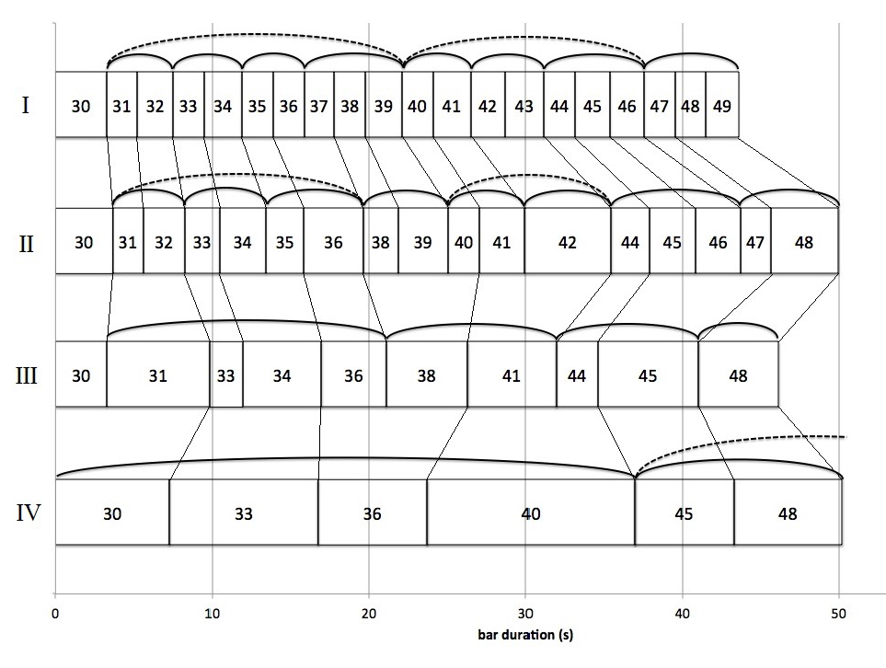
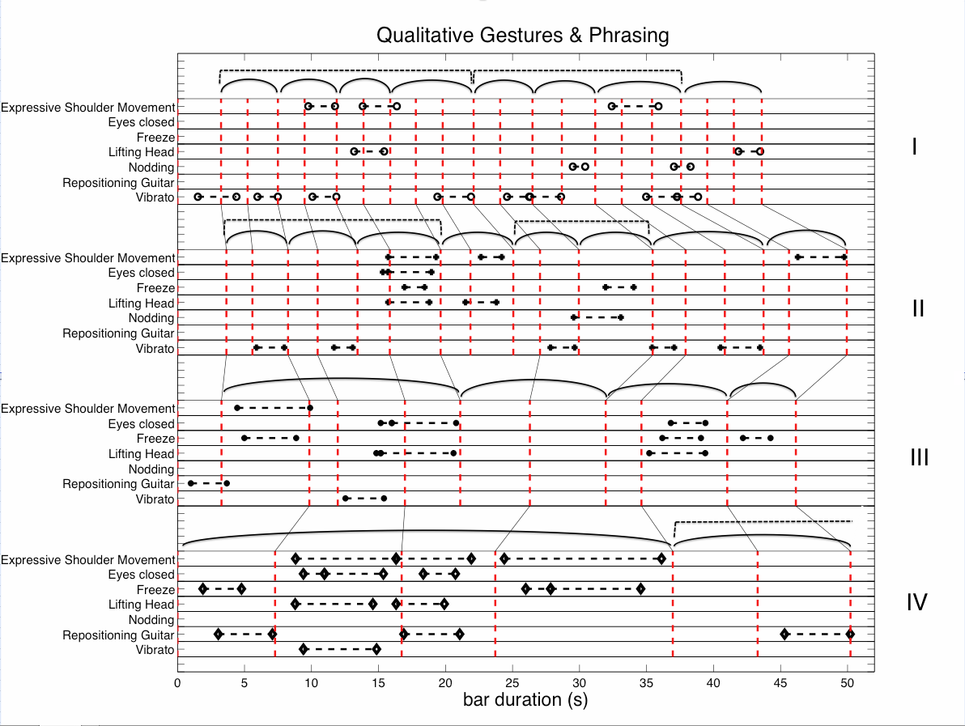
Fig. 9a Perceived phrasing in bars 31-49 for each run-through with the duration of each bar.
Fig. 9b Perceived phrasing in bars 31-49 for each run-through with the duration of each bar and a list of some annotated gestures.
The perceived phrasing, at last, could be linked both with the onset timing of the bars, the annotated gestures and the movement data. Figure 9a gives a representation of bar 31-49, the section with the ascending arpeggios. Each cell represents the duration from the start of a bar to the beginning of the next, with the numbers indicating which bar each cell represents. The four horizontal layers represent the four run-throughs, and the vertical and diagonal black lines between them show the relative repositioning of the surviving bars. The curved lines on top of the cells represent the agreed phrasing structure. Thus, in the first run through, we found bars 31-46 to be shaped into 7 units that can be perceived also as two super phrases, each super phrase ending with a longer phrase (three bars instead of two).

Fig. 10 QoM and perceived phrasing of the second and third run-through for bar 30-36 (top) and of the first run-through for bar 13-24 and bar 25-30.
The gradual process of cuts is reflected in the shaping of the music in the following run-throughs. In the second round, the music between bars 31 and 46 is again divided into 7 smaller units, shaped somewhat differently due to bars 37 and 43 being cut out. In principle, the lower level structure looks similar, but the perceived higher structure is divided into different super-phrases. Here, the duration of the last bars in the sub-phrases (= bars 32, 34, 36, 39, 41, 46, 48) are longer (M = 3.25s) compared to the others (M = 2.58s). In the third round, the number of bars lost is more radical and the music of bars 31-45 is now shaped into three units spanning across a number of empty bars, again with the last bar of each phrase being longer (except for bar 36). In the fourth round, the music has in a sense gone full circle and again consists of only two long phrases: one that stretches from bar 30 (before the section we are discussing here) up until bar 40, and one starting in bar 45 and stretching again outside of the section, now ending in bar 48, and with a super-phrase stretching far into the next section of broken chords, ending at bar 56. The changing musical structure of the piece cause different emerging timing and phrasing patterns, and in this final run-through, we see how the previously defined limits of the different sections break down, with materials from the different sections becoming joined together within the new phrase structure.

Figure 9b combines the timing and phrasing information from the previous image with some of the more commonly appearing qualitative codes for this section. Some movement patterns are consistent between the rounds. Notably, bar 36 is always shaped by a lifting of the head and, apart from in the first round, also with the eyes shut. The entire section is characterized by the code “expressive shoulder movements”, especially in the section between bars 34 and 36, but these movements seem to be particular for the material at large, being connected to the shaping of phrases stretching over two or three bars. They occur frequently in the first two run-throughs when the material is largely continuous. Of more importance here is the introduction of new gesture material starting in the second round. In bars 37 and 43 we find the new code “freeze”, which denotes a relative stillness and marks the first silent bars. The new pacing of the music is immediately reflected in the performer’s choreography of movement. Interestingly, when the bars in the score become more cut out, the expressive shoulder movements are now, instead, aligned either with the “freeze” or the “lifting head” codes. Hence, the new shape of the music that emerges - both the shaping of the music in long lines and the later fragments between long silences - are clearly projected and connected through body movement.

The musical structure in terms of perceived phrasing is also reflected in the QoM pattern (Fig. 10). Consider bar 30 – 36 in the 2nd and 3rd run-through. In both cases these bars are connected in one big phrase, and despite the loss of musical material in the 3rd run-through, the movement pattern looks very similar. Also, the super phrase in bar 13 – 24 and bar 25 – 30 in the first run-through show a similar profile, starting with a low QOM, and then a sudden increase. Remarkable as well: the 1st bar in the 1st and 2nd run-through belong to a super phrase, while in the later run-throughs, it stands on its own. When being the starting point of a super-phrase, there is a relatively low QoM, when standing alone, the QoM is relatively high.

Consolidation. To consolidate this mixed approach, the conclusions that were drawn from the different layers of analysis were discussed with the whole team. This last of the ‘top-down’ methods was necessary to verify the detected targets and to fully understand the observations made. The comparison of the timing in the different sections of the piece showed that there is a clear change between the second and the third run-through in the second section, which was clearly shorter. We can explain this by its musical content, as it consists of arpeggiated harmonics. The resonance of these tones is shorter than that of the chords, aggregates and fully-stopped tones used in the other sections. This forces the performer to compress the gaps, in order not to create excessively long silences.
Considering the musical targets, the viewpoint of the performer is fundamental. In the version discussed here, the reason bars like bar 15 and 59 are played in all the four run-throughs is because the performer deliberately chooses to do so, as they are of musical importance for the performer to structure the piece. Bars 26-28 by contrast seemed to be a questionable target. The performer reported that bar 26 and 28 are technically difficult bars with some artificial harmonics that demand rapid movements in both hands. The QoM does not indicate an expressive target here, but rather informs us of technical actions. When verifying this with the video recording, the increasing velocity in shoulder and wrist were caused mostly by the artificial harmonics to be played. Bar 30-33 also implies some technical difficulties, as the big shift in position on the fingerboard demands more physical action. The movements and bodily gestures are not unlike those of the way the musical shapes are disposed over the fret board and hence also in the trajectory of the left hand, but this contrasts with the general decrease in QoM during bars 41-51, where there are a lot of position shifts too.

- Discussion and conclusions
Establishing a multimodal framework for analysis. The methodology developed in this paper provides a framework for the multimodal analysis of music performance. The bottom-up approach consisted of a timing analysis at different structural levels and an analysis of movement-data using low-level descriptors as QoM, velocity and acceleration. These descriptors are related to more high-level features as movement intensity and energy, but don’t relate immediately to semantic descriptors or the performers’ intentions. This might be considered as an important gap, as we often interact with and understand music at this level [4]. Therefore, the coding and annotations from the stimulated recall sessions and the perceived phrasing were added as a top-down approach. Next, the different analytical layers were compared and finally, the observations made were evaluated, which is crucial to get a reliable and meaningful interpretation of the data (Fig 11).
During the process of analysis, some important observations were made that highlight the importance of a multimodal analysis when dealing with music performance. First of all, the findings from the analysis at different layers can reinforce each other. The compression of musical time that was observed in the different sections of the piece was nicely reflected by the changing QoM of the performer’s body and the perceived phrasing, while the distribution of musical gestures along the piece reflected the change in musical material throughout the 4 repetitions of the piece. The mutual comparison of QoM, velocity and acceleration data with the annotated gestures on its turn, allowed identifying some important musical targets. The perceived phrasing also appeared to be a useful feature in the comparison of different modalities (timing, gestures, QoM) and highlights the importance of phrasing as a strategy of structuring the music by means of chunking and co-articulation for both performer and listener.
Perceived Phrasing
Consolidation
Top-Down
Gesture Annotation
Kinematics
Bottom-up
Timing
QoM
Bottom-up
Fig. 11: Summary of analysis framework

On the other hand, the multiple layers sometimes appeared to be contradictory. In some cases, the general body movement (QoM) showed a different behavior than the more detailed analysis of wrist and shoulder movements (e.g. bars 15-16 and 58-59). This means that different body parts are not engaged in the same way during performance, which is consistent with previous findings on violin/viola performances [24]. Also, the annotated gestures did not always reflect the change in QoM, for example an increase in QoM coinciding with annotated ‘minimal movement’.
In the end, the viewpoint of the performer and composer appeared to be crucial for the interpretation of the analysis, e.g. some possible musical targets were discarded, as they were mere technical difficulties in the piece than real expressive targets. The collaboration between composer, performer and musicologists allows for the development of a methodology for performance analysis that helps interpreting the multiple data-streams, involving the expressive intentions that eventually lead to musical creativity and expressivity.

Future work. The framework established here offers a valuable instrument for future analysis. Three other performances of the piece were recorded using the same set-up. Observations over the different performances could give additional information on how the musician applies body movements to structure and shape the performance and to communicate his intentions and the musical structure that emerge from the deconstruction of the piece to the audience. Moreover, a more detailed analysis of the expressive intentions of the performer as emerging from the score, the timing and characterization of gestures and performance cues at the note instead of the bar-level, together with a more thorough comparison of the different levels of analysis could provide a richer information and a better understanding of what we perceive as musical expressivity. If gestures are consistently related to certain materials one might be able to trace an ‘expressive musical structure’ from the mapping of the different layers of analysis.
This is also reflective of Lachenmann’s idea that composition is a creative process of building an ‘instrument’, together with the performer, an idea that was also postulated by Clarke et al. [11]. The choreographic aspects of performance and the idea that bodily gestures make the music, is an idea worth to explore in the future. It would be wrong to think that the performer’s movements are simply the result of emergent processes of embodiment, simply reflecting the music: in performance, the deliberate body strategies of the musician bear an explicitly choreographic aspect. On the one hand, these bodily gestures seem to be liberated from the music, but on the other hand, the music will get increasingly embodied. The musical performance is a result of the interplay between deliberate choices and intentions and spontaneous and unconscious behavior, and this is where the perspective of the performer is of key importance. In developing a theory on musical expression, the intentions of the performer, and hence it’s subjectivity, are part of a crucial body of knowledge that is important in understanding the final realization and enactment of a performance. This seems rather trivial or obvious, but it is an aspect of performance that is often neglected or forgotten in research analysis, the more because this subjectivity is difficult to describe and access.
From this study, it is clear that the collaboration between musicians, performers and scholars should be encouraged in order to establish a corpus of studies that access expressive music performance from a multimodal perspective. The intriguing role gestures play in the shaping of a musical performance, and the interplay between musical timing, movement, expression and musical meaning is a rich field that can be explored and accessed in detail with the multimodal perspective established in this paper.

Acknowledgements. This study was partially realized under the FWO-project “Foundations of expressive timing control in music”. Special thanks to Ivan Schepers, who helped developing the pressures sensors and mo-cap markers and Frank Desmet, who assisted in the analysis of the pressure sensors.

References
- Godøy, R.I., Leman, M. (eds.): Musical Gestures: Sound, Movement, and Meaning. Routledge, New York (2010)
- Windsor, W.L.: An Ecological Approach to Semiotics. J. Theory Soc. Behav., vol. 34, pp. 179-198 (2004)
- Clarke, E.: Ways of Listening: An Ecological Approach to the Perception of Musical Meaning. Oxford University Press, Oxford (2005)
- Leman, M.: Embodied Music Cognition and Mediation Technology. MIT Press, Cambridge, MA (2007)
- Maes, P-J., Palmer, C., Leman, M., Wanderley, M.M.: Action-Based Effects on Music Perception. Front. Psychol., vol. 4, no. 1008 (2014)
- Davidson, J.W.: Qualitative Insights Into the Use of Expressive Body Movement in Solo Piano Performance: a Case Study Approach. Psychol. Music. vol. 35, pp. 381-401 (2007)
- Wanderley, M.M., Vines, B., Middleton, W.N., McKay, C. and Hatch, W.: The Musical Significance of Clarinetists’ Ancillary Gestures: An Exploration of the Field. J. New Music Res., vol. 34, pp. 97-113 (2005)
- Gritten, A., King, E.: Music and Gesture. Ashgate, Hampshire (2006)
- Davidson, J.W.: Bodily Communication in Musical Performance. In: Miell, D. Macdonald, R., Hargreaves, D.J. (eds.) Musical Communication pp. 215-228. Oxford University Press, New York (2005)
- Godøy, R. I.: Reflections on Chunking in Music. In: Schneider, A. (ed.) Systematic and Comparative Musicology: Concepts, Methods, Findings, pp. 117-132. Peter Lang, Frankfurt am Main (2008)
- Clarke, E., Doffman, M., Timmers, R.: Creativity, Collaboration and Development in Jeremy Thurlow’s Ouija for Peter Sheppard Skaerved. In: J. Royal Musical Ass. (in press).
- Desmet, F., Nijs, L., Demey, M., Lesaffre, M., Martens, J.-P., Leman, M.: Assessing a Clarinet Player’s Performer Gestures in Relation to Locally Intended Musical Targets. In: J. New Music Res., vol. 41, no. 1, pp. 31-48 (2012).
- Godøy, R. I., Jensenius, A. Voldsund A. et al.: Classifying Music-Related Actions. In: Proceedings of the ICMPC-ESCOM 2012 Joint Conference: 12th Biennial International Conference for Music Perception and Cognition, 8th Triennial Conference of the European Society for the Cognitive Sciences of Music, pp. 352 – 357 (2012).
- Thompson, M. R., Luck, G.: Exploring Relationships Between Pianists’ Body Movements, Their Expressive Intentions, and Structural Elements of Music. Music. Sci., vol. 16, no. 1, pp. 19-40 (2012)
- Fabian, D. Timmers, R., Schubert, E. (eds.): Expressiveness in Music Performance: Empirical approaches across styles and cultures. Oxford University Press, Oxford (2014)
- Cycling ‘74: Max/MSP [Computer program]
https://cycling74.com/products/max/ (2005)
- Troillard, C.: OSCulator [Computer program] http://www.osculator.net (2012).
- Boersma, P., Weenink, D.: Praat: Doing Phonetics by Computer [Computer program] (2013)
- Bloom, B.S.: Thought-Processes in Lectures and Discussions. J. Gen. Edu., 7, p.161 (1953)
- Jensenius, A.R., Wanderley, M.M. Godøy, R.I., Leman, M.: Musical Gestures: Concepts and Methods in Research. In: Godøy, R.I., Leman, M. (eds.) Musical Gestures: Sound, Movement, and Meaning, pp. 12-35. Routledge, New York, London (2010)
- ResearchWare: HyperRESEARCH: Cross-Platform for Qualitative Analysis. [Computer program] http://www.researchware.com/products/hyperresearch.html (2015).
- Burger, B., Toiviainen, P.: MoCap Toolbox: A Matlab Toolbox for Computational Analysis of Movement Data. In: Bresin, R. (Ed.) Proceedings of the 10th Sound and Music Computing Conference Stockholm, Sweden: KTH Royal Institute of Technology (2013)
- Dempster, W.T., Gaughran, G.R.L.: Properties of Body Segments Based on Size and Weight. American J. Anatomy. vol. 120, no.1, pp. 33-54 (1967)
- Visi, F., Coorevits, E., Miranda, E., Leman, M.: Effects of Different Bow Stroke Styles on Body Movements of a Viola Player: an Exploratory Study. In: Proceedings of The joint ICMC|SMC|2014 Conference. Athens, Greece (2014)

‘Stimulated recall’ is the overarching term for introspective research procedures through which cognitive processes can be investigated by inviting subjects to recall their thinking during an event when prompted by a video sequence. Benjamin Bloom is considered the first to use the term in 1953, which he described as a method for retrieving memories: “The basic idea underlying the method of stimulated recall is that a subject may be enabled to relive an original situation with vividness and accuracy if he is presented with a large number of cues or stimuli which occurred during the original situation.” [18]
The filtering and smoothing process was based on the methods used in [12], where noise-measurements are used to obtain the most reliable smoothing result.

