**RESEARCH ARTICLE**

**Choose your own adventure music: on the emergence of voice in musical collaboration**

David Gorton and Stefan Östersjö

*Royal Academy of Music, University of London, London, UK; Malmö Academy of Music, University of Lund, Malmö, Sweden*

Research conducted at the Royal Academy of Music, the Malmö Academy of Music, and the Orpheus Institute, Ghent, Belgium.

The practices of collaborating composers and performers have been receiving increasing attention within academic discourse. Such collaborations are often presented from two complementary perspectives: pre-compositional joint invention and post-compositional negotiations in the realization of a score and its notation. This article attempts to bridge the gap between the two perspectives through a discussion on the emergence of ‘voice’ that pervades the artistic practice, and binds the pre- and post-compositional phases together. Two compositions by David Gorton, written in collaboration with guitar player Stefan Östersjö, will be examined: *Forlorn Hope* for eleven-string alto guitar and optional live electronics and *Austerity Measures I* for ten-string guitar. Both pieces are the result of an extended pre-composition experimental phase, and both pieces attempt to recreate something of those experiments in the contexts of their performance, establishing the conditions for the emergence of a ‘discursive voice’ of both composer and performer.

**Keywords:** affordance; collaboration; composer; guitar; performer; resistance; voice

**Introduction**

Collaboration, as a term, has been knocking around the contemporary music vernacular[1] for some time, and is generally taken very broadly to mean the kinds of interaction that might go on between composers and performers beyond the most obvious division of labour; that is, beyond a composer just writing a piece, and a performer then playing it.[2] This could include on the one hand a simple negotiation in rehearsal of how a piece might be performed, or on the other hand a fluid, improvisational, co-creation of a musical outcome. Of course, within these terms, composers and performers have arguably always collaborated in one way or another,[3] yet there remains within classical music a powerfully embedded division between the two respective roles of creator and executor, far more so than in other kinds of music and performing arts (Clarke, Doffman, and Lim, 2013, p. 628). One possible reason for this division is that while most composers could reasonably expect to have some interaction with the people who are going to play their compositions, the vast majority of classical performers only play music by people who are dead, often long dead, and so are unable to interact with them, even if they wanted to. Indeed, the very idea of the transmission of music beyond the death of its creator, the idea that underpins the work concept and the entire repertory of Western Art Music, predicates and perpetuates the division between composer (dead, yet immortal) and performer (alive, yet transitory).

But, in apparent opposition, the collaborative practices of composers and performers has been the focus of interest in recent academic writing, with a variety of such collaborations presented at conferences and the focus of academic book chapters and journal articles.[4] It is difficult to say exactly what has changed within practice to trigger this interest, but one significant change over the last couple of decades is that of technology. At the turn of the millennium recording a rehearsal on video was a difficult and daunting prospect. Video cameras existed of course, but the quality of video and audio was by today’s standards relatively poor, and the process of editing the video was cumbersome. Today most people carry around with them a camera on a phone or tablet that can take good video and audio, and for a reasonably small outlay it is easy to get hold of a portable high-definition camera. Video editing software is widely available for free, and digital video editing techniques on tablet devices are now taught in year 3 at primary schools.[5] It is not surprising that an increased ease in recording collaborative processes has led to an increase in recorded material that is then shared and discussed within academic circles.

Another reason why there has been recent interest in collaborative practice in academic writing is that in the last decade there has been increasing pressure from funding bodies and universities on staff composers and performers to show that their work is research, rather than ‘just’ composition or performance. The discourse regarding the ontology of practice-based (or practice-led, or whatever you want to call it) research is multi-faceted and alarmingly changeable, as is the associated policy and guidance.[6] But the ability of practitioners to easily document their work on video, and then write about it and analyse it, has enabled them to identify the artistic processes within their work. As Fitch and Heyde observed, ‘it is actually the process of discovery or “invention” within the piece that best represents the way in which its coming into being, and thus its ‘“research aspect”, is inscribed within it’ (2007, p. 93). Furthermore, in many cases such writings become an invaluable companion to the artistic work, particularly when the artistic practice is open-form in character and involves a number of participants.[7]

Beyond practitioners themselves, the use of collaborative case studies has contributed to a wider field of enquiry, and possibly has provided fresh ammunition for the long-term deconstruction of the work concept. Amanda Bayley, for example**,** focuses on a collaboration between Michael Finnissy and the Kreutzer Quartet in order to develop a methodological discussion; in suggesting an ethnomusicology of recordings she highlights the emic and etic principles of insider and outsider narratives in her own fieldwork with Finnissy and the Kreutzers (Bayley, 2010). Similarly, Eric Clarke, Mark Doffman, and composer Liza Lim identify various interactions in Lim’s collaboration with the ensemble musikFabrik on her piece *Tongue of the Invisible*. By drawing on writings by anthropologists Georgina Born and Tim Ingold, which in turn discuss music’s mediation and the ontology of making things, they propose an ecology of distributed creativity that describes ‘how the dynamic and fluid processes that converge and entangle in the making of [*Tongue of the Invisible*] are distributed in time, space, and level’ (Clarke et al., 2013, p. 658). In general terms then, these case studies can be seen to critique the apparently defined and embedded roles of composer and performer, and the division between them, and to propose a more fluid understanding of the relationships at work in practical music making.

Much of the published case studies in collaboration could be said to be presented from two complementary perspectives. Firstly, the perspective of pre-compositional joint invention, where composer and performer work together before the main compositional work is done, developing instrumental techniques or proto-materials that might then be used later in a piece. Secondly, post-compositional negotiations in the realization of a score and its notation, where composer and performer work together on a score after it has been written, perhaps editing the notation, and jointly developing ideas about its interpretation. Both of these perspectives are valuable, and the examples that follow will align to them in their presentation and discussion. But beyond that, the aim of this article is to attempt to bridge the gap between the two perspectives through a discussion on the emergence of ‘voice’ (Cumming, 2001) that pervades the artistic practice, and binds the pre- and post-compositional phases together. It is argued that, not only is the emergence of voice a defining feature of becoming a musician, but that in collaborative artistic practices individual voices may join into what can be termed a ‘discursive voice’. Finding such a voice is what makes collaboration ‘worth doing’ in the first place. Rather than providing materials to be studied, or identifying the research component of artistic work, this article ultimately aims to show some of the artistic imperatives for collaboration, at least from the point of view of the authors, and discuss the creative opportunities afforded by the discourse of artistic voices.

**Part 1: the Malmö sessions**

The two compositions that will be discussed are *Forlorn Hope* for eleven-string alto guitar and optional electronics, and *Austerity Measures I* for ten-string guitar.[8] These compositions shared a pre-compositional collaborative phase that took place in Malmö on 9 and 10 June 2010. The collaborative work was recorded on video, and can be divided into four distinct sessions.[9] The first session took place on the evening of 9 June, during which Östersjö introduced Gorton to the 10-string guitar and the 11-string alto guitar, instruments that Gorton had not previously encountered. Overnight, Gorton developed three tuning systems, to be tried out the following day, each of which use an alternating pattern of strings that are equally tempered (i.e. in tune with a piano), and those that are tuned a sixth of a tone sharp or flat. This retuning is achieved by using the naturally flat seventh harmonic as a reference pitch. Figure 1 shows the first of these tuning systems, which was eventually used on the eleven-string guitar in *Forlorn Hope*. Strings 2 and 4 are tuned so that they are in tune (at the octave) with the seventh harmonic of strings 7 and 11 respectively. Strings 6, 8, and 10 are tuned so that their ‘out-of-tune’ seventh harmonics become in tune with the respective pitches found on string 1.

Figure 1. Tuning system for eleven-string alto guitar in *Forlorn Hope*.

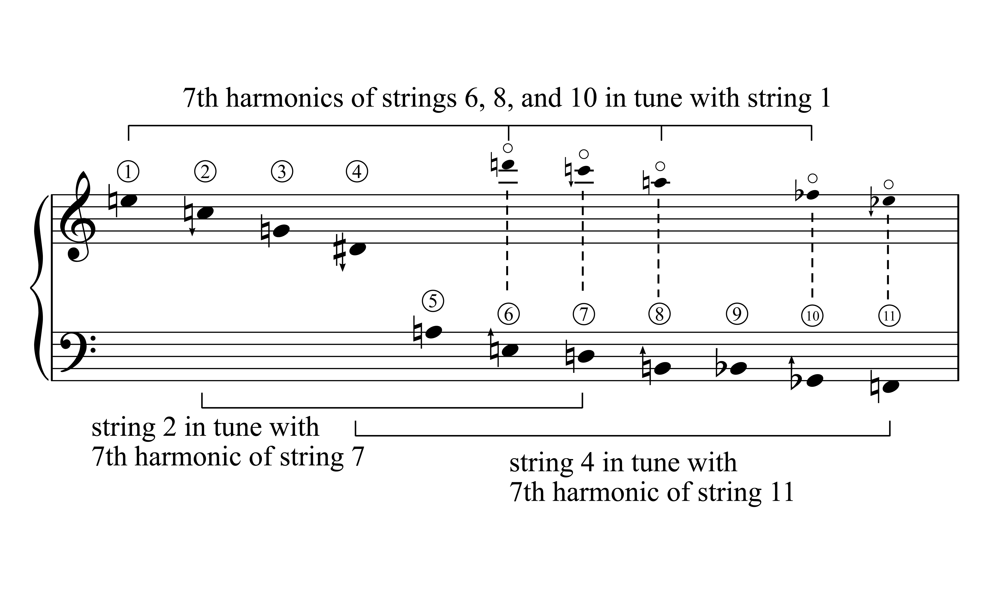

Table 1 provides an overview of the four sessions. The first and last sessions most closely resemble the widely held and anecdotal view of what collaboration might look like.[10] Östersjö is demonstrating the instruments and responding to Gorton’s questions about them, and this demonstration leads to discussion. In the first session the instruments are the ten- and eleven-string guitars with discussion about range, tuning, notation, and general guitar techniques; in the fourth session the instrument is the six-string guitar with demonstrations of Elliott Carter’s *Changes* and Rolf Riehm’s *Toccata Orpheus*, the latter provoking interesting questions about right and left hand movement across the instrument. The amount of time that Östersjö spends playing is around half, and less than half, of the total duration of each session, with the rest of the time spent talking and showing.[11]

Table 1. Overview of the Malmö sessions.

|  |  |  |  |  |
| --- | --- | --- | --- | --- |
| **Session** | **Duration** | **Time playing** | **Instrument** | **Description** |
| 1. Instruments | 62.5 min | 52% | 11-string alto guitar  10-string guitar | Demonstration of instruments.  Discussion of range, tuning, general guitar techniques, and notation. |
| 2. Tuning system 1 | 89.7 min | 89% | 11-string alto guitar | Testing of the 1st tuning system.  Development of glissing/tapping/trilling material. |
| 3. Tuning systems comparison | 65.2 min | 87% | 11-string alto-guitar  6-string guitar | Testing and amendment of 2nd tuning system.  Discovery of bell-like qualities.  Comparison with 1st tuning system.  Testing of 3rd tuning system. |
| 4. Repertoire | 28.6 min | 37% | 6-string guitar | Demonstration of repertoire.  Discussion of the notation of left- and right-hand action. |

Sessions two and three provide quite a contrast. Here, demonstration and discussion are replaced by testing, discovery, and development. In the second session the first tuning system is tested by playing open strings, dyads, harmonics, chords, and scale passages across the strings. Following a brief discussion about glissandi, a particular glissing/tapping/trilling technique is developed that forms the basis of extended amounts of playing. In the third session the second tuning system is tried, and it is decided that the interval qualities of the lower strings should be amended. The bell-like qualities of the subsequent altered tuning are explored, and then compared with the first tuning by moving to and from the different set-ups. Finally, a third tuning is tested on the six-string guitar.

Most striking of the second and third sessions is the amount of time that Östersjö spends playing: nearly 90% of the total duration of the sessions. This includes interruptions, comments, and suggestions from Gorton, and some discussion, which cuts across the playing, but unlike in the first and last sessions the talking rarely brings Östersjö’s playing to an actual stop. The character and function of this playing is different too; this is a kind of playing that is more than just demonstration, but does not have quite the structured coherence or intentionality that might be associated with an ‘improvisation’. There are testing qualities, where Östersjö is familiarizing himself with the specific tuning, or trying specified techniques in a variety of registers or within the contexts of other materials. But there is also a generative quality where new materials are spontaneously articulated and then developed.[12]

From the video documentation three methods can be identified that underpin the interactions in these sessions. First, analytic interpretation that emerges from the notated structure: this largely refers to comments made about the technical aspects of the tuning system, but also relates to the kind of movements that can be drawn out from a written glissando. Second, verbalized interpretation of listening: here both participants describe what they are hearing and make verbal suggestions on how to develop it. Third, non-verbal processes of thinking-through-listening (Östersjö, 2008): this is a kind of thinking that involves the physical interaction between a performer and instrument, and the listening of the composer, both of which are modes of thinking that do not require verbal ‘translation’. Instead they function through the ecological system of auditory perception.[13]

The theory of situated cognition (see e.g. Brown, Collins, and Duguid, 1989) is helpful when considering the emergence of subjectivity in the Malmö sessions. Closely related to the work of James Gibson and ecological psychology, it suggests that the source for subjectivity is the human body in interaction with the environment. Musical perception is multi-modal (Livingstone and Thompson, 2006) and many studies confirm direct connections between the physical movement of the performer (visual gesture) and sonic gesture in musical performance (Henbing and Leman, 2007; Desmet, Nijs, Demey, Lesaffre, Martens, and Leman, 2012; Thompson, Graham, and Russo, 2005). Human perception of music is not acousmatic but is stored as motor-mimetic images of movement, action, and sound (Godøy, 2006). Furthermore, music cognition is considered to be situated, that is, embedded in an environment, and enacted, or, put into practice through action (Varela, Thompson, and Rosch,1991; Barsalou, 2008). Along the same lines, Marc Leman argues that ‘musical communication is based on the sharing of neural structures that pertain to movement’ (Leman, 2008, p. 161). His theory of musical communication builds on the assumption that intention is projected to music in the same way as in other social interaction. In musical performance, patterns of sonic energy evoke bodily gestures that are culturally meaningful to an individual because our imagination is embodied. Further, Livingstone and Thompson conclude that our musical capacities are founded in how we learn affective cues during infancy, but musical creativity ‘emerges from our capacity to engage with symbolic hierarchical systems, our desire for affective social communication, and a reflexive motivation to explore our identity’ (2006, p. 92).

The diagram in Figure 2 reflects an understanding of subjectivity formation from the perspective of the performer based on situated cognition, identifying the various agents involved and how they interact towards the formation of subjectivity of composer and performer. First, a musician interacts with the affordances of a musical instrument. One may think of the way in which a musician learns to play with the resistances and the affordances of an instrument, a process that may call for ten thousand rehearsal hours and is the heart of the formation of a performer’s habitus (Coessens and Östersjö, 2014). Here, embodied knowledge is gradually built; it may consist of musical strategies towards the shaping of materials, particular ways of controlling rapid finger work, ways in which an instrument would best resonate with a hard attack and so on (Östersjö, 2012). We may, following Merleau-Ponty, think of the function of the instrument as an extension of the body similar to a blind man’s stick (Merleau-Ponty, 2002, pp. 175-177).

The human body is multi-layered. The distinction between body image and body schema is helpful to create an understanding of these ‘emergent processes’. The body image is an intentional state made up of several modalities: perceptual experiences of one’s own body, conceptual understandings of the body in general and emotional attitudes towards one’s own body (DePreester, 2007, p. 355). The body schema on the other hand involves ‘a system of motor capacities, abilities and habits’ (Gallagher and Cole, 1995, p. 370). A musician’s voice, then, emerges from the interplay between the affordances of an instrument, one’s habitus, and the natural body. It may be argued that these processes are largely subconscious and drawn substantially from the level of the body schema.

Figure 2. Subjectivity formation from the perspective of the performer.

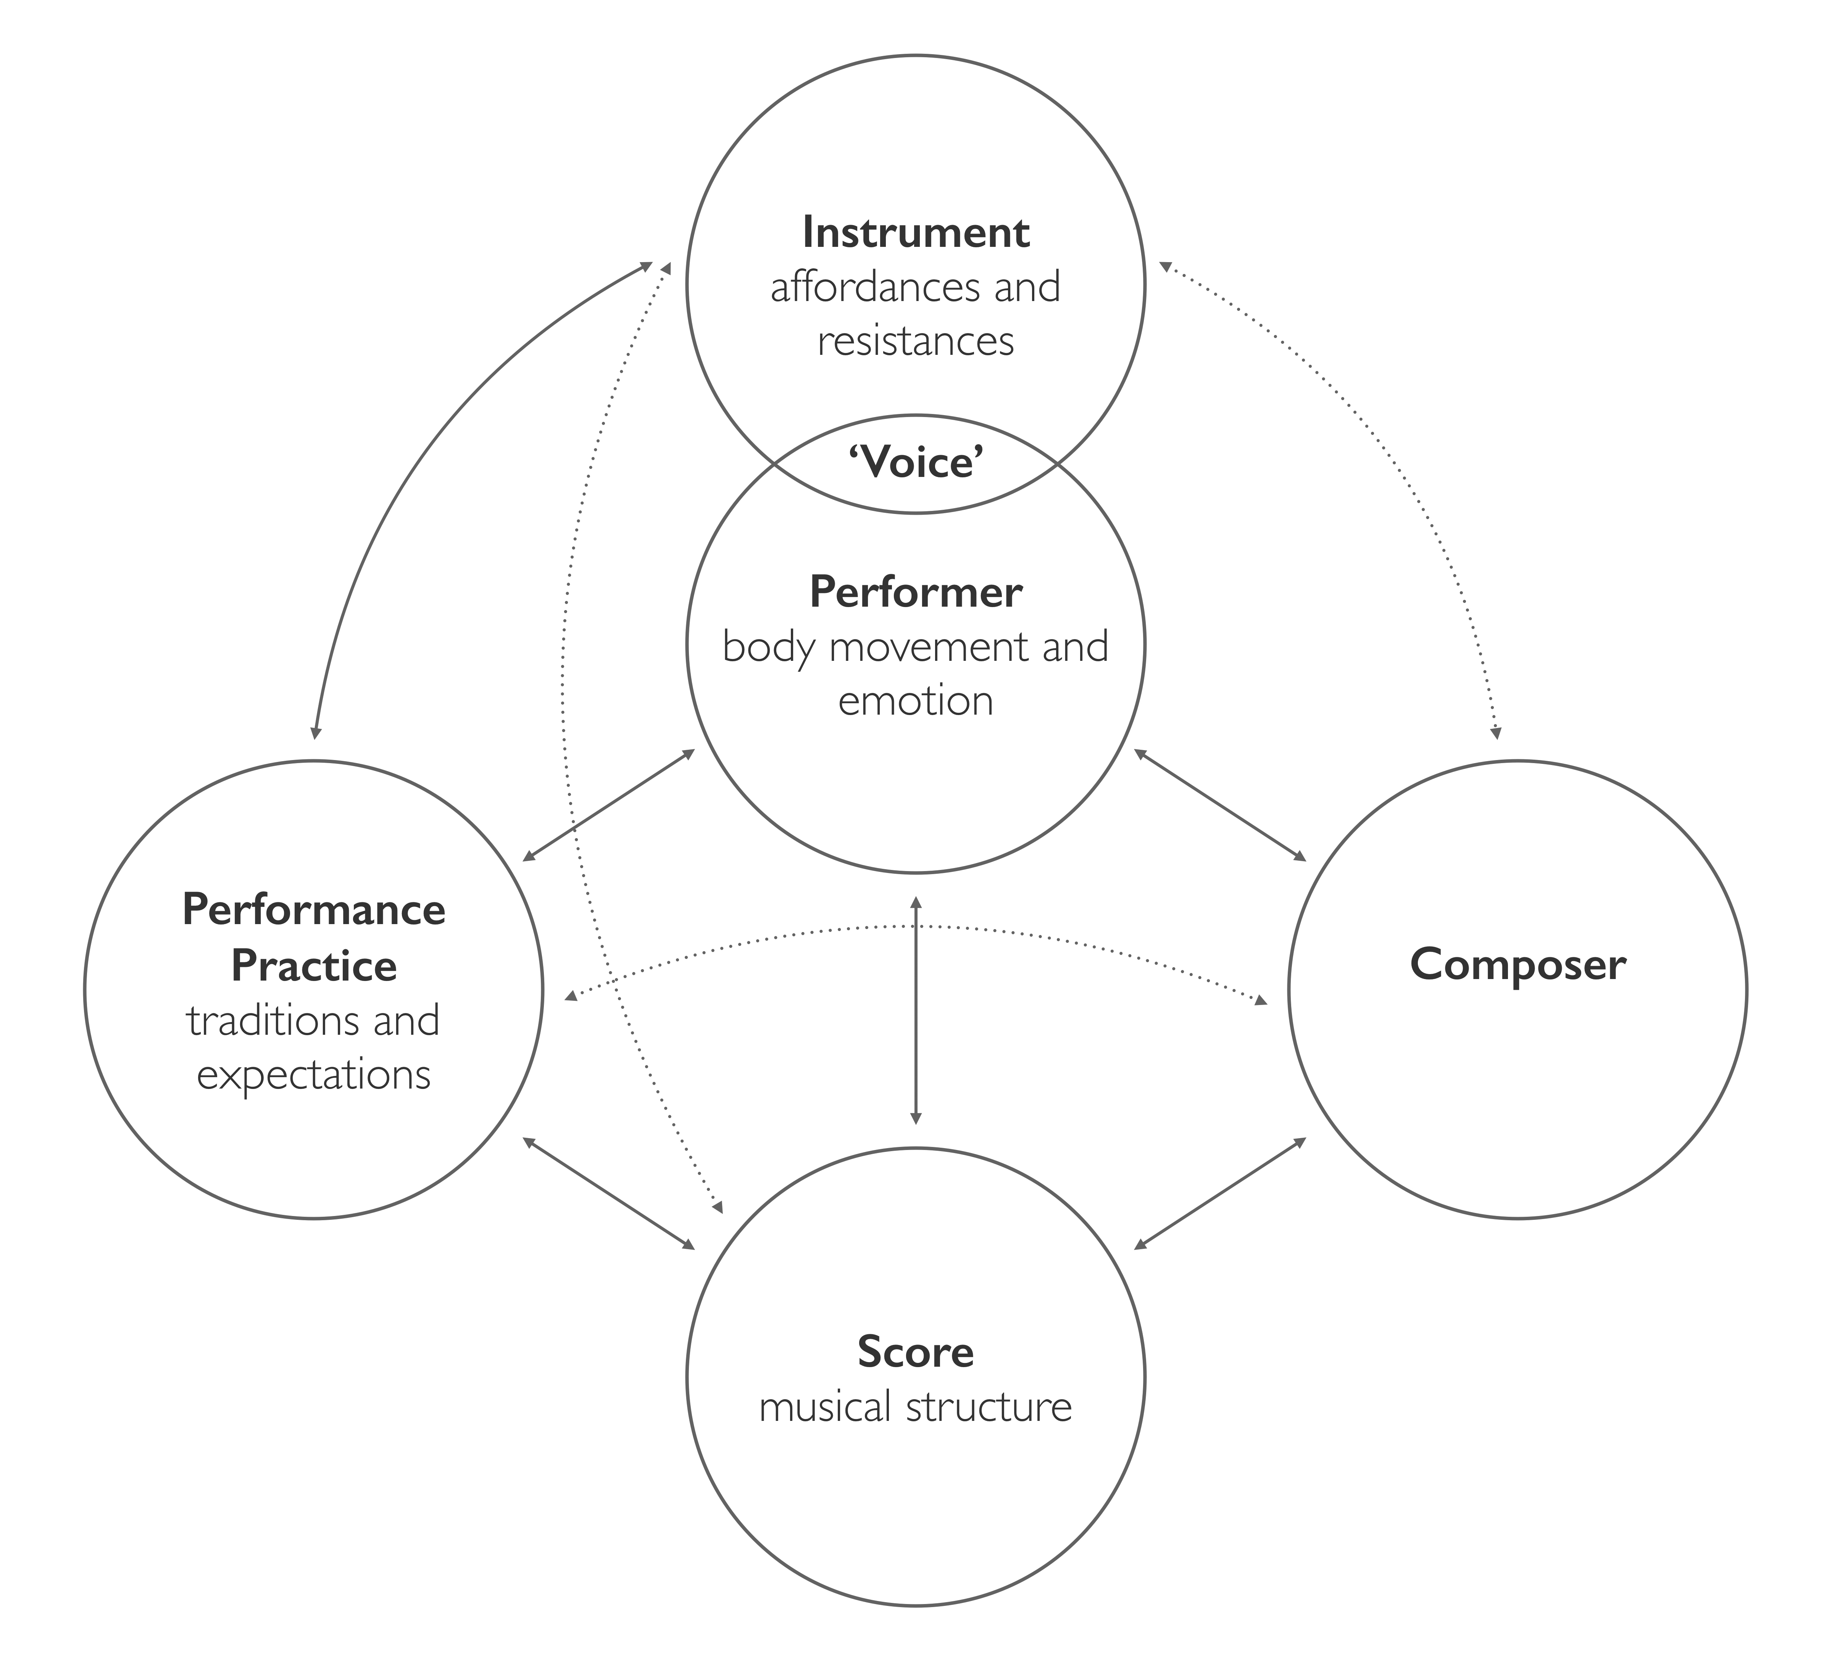

During the interactions between Gorton and Östersjö in the Malmö sessions the agency of the instrument is strong. The score consists merely of the tuning systems, although in the discussion of the glissing/tapping/trilling material a compositional idea from an earlier piece becomes the very starting point for the development of the new playing technique. The structures of the tuning systems launch a number of analytical interpretations and reflections, especially from the composer, and the affordances of the instrument in a particular tuning system engages both performer and composer (Clarke, et al., forthcoming). The specificity of these tuning systems and the consistent function they have had throughout many years of compositional work may explain why they exert such a strong agency. Already the scordatura holds so many resistances and possibilities that they function like a fundamental compositional structure. This would not be the case with an open tuning of a more conventional character. A guitar tuned to a C-major chord may afford many different modes of playing but cannot be understood as a compositional structure, because of the universal application of the resulting sonorities within the Western tradition; but just as in Lachenmann’s compositional practice, where the building of an instrument is a fundamental principle, here, the tuning system becomes a physical manifestation of the compositional process and indeed rebuilds the instrument (Lachenmann, 1996, p. 77).

In these sessions, the composer’s voice can be heard through these tunings. Obviously, it is only at the point in the moment of writing that the voice takes more defined shape. The performer’s voice is more immediately apparent. The exploratory playing described above is guided by classical guitar techniques and its performance practices, as well as by the performance practices of free improvisation. It may be argued that the performer’s voice is drawn from, and to an extent moderated by both of these traditions[14]. The diagram in Figure 2 is an attempt at identifying the complex agency of and interactions between performer, instrument, composer, scores, and performance practices, from which subjectivity emerges. Scott Marratto observes, ‘The point is that a self is, first of all, a being-in-a-situation. As Merleau-Ponty says, following Husserl, subjectivity is not first and foremost revealed as an “I think [je pense que], but as an “I can” [je peux]’ (Marratto, 2012, p. 20). It may be fair to say therefore that in the 2010 Malmö sessions described here, most of the musical interactions are less about working towards an intended goal than about exploring a situation in the present.

**Part 2: choose your own adventure in *Forlorn Hope*[15]**

The first piece to emerge from the Malmö sessions was *Forlorn Hope* for eleven-string alto guitar and optional electronics. The transcription and transferal of proto-materials from the Malmö sessions into the notated materials of *Forlorn Hope*, including the glissing/tapping/trilling material and the characteristics of the tuning system itself, have been documented elsewhere (Clarke et al., forthcoming). But in this section the emergence of voice will be considered in relation to the structural characteristics of the piece.

Gorton’s conception of musical structure is informed by the writings of the philosopher J. T. Fraser (Fraser, 1982 and 1990). Fraser attributes the conflicts between the nomothetic and generative aspects of time (permanence/change, duration/succession, stasis/process, and their many corollaries) to a ‘universal condition’ that he describes by the ‘purposefully broad concept of existential tension’ (Fraser, 1990, p. 46). With the mental enrichment of the present with memory of the past and expectations of the future, the human experience of time can be understood with reference to this existential tension, and to the balance between the various pairs of conflicting opposites that can be collected under the blanket terms *being* and *becoming* (ibid., p. 44).[16]

Fraser’s model for a human experience of time is useful when considering the experience of listening to music, and the ways in which music is structured in its temporal unfolding. This phenomenological concept of musical structure, distinct from the objective evaluations usually associated with the word, may also be expressed through a perceived temporal conflict, and the changes in the balance between *being* and *becoming* that are perceived as inherent in the musical material across short-, medium-, and long-term durations.[17] Such perceived changes may be understood through a complex interaction of harmony, rhythm, and the other various qualities and characters of the material itself.[18]

If considering musical structure from the perspective of an experiential unfolding through time, it follows that a performer may conceive a plurality of structures in the presentation and interpretation of musical materials, resulting in a variety of different performed structures of the same piece. For the manner in which a performer chooses to articulate a material’s rhythmic organization, to choose just one example, whether suppressing or enhancing the pulsations, can alter the perceived propulsion of the material. Musical structure, as understood in these terms, therefore attains a *malleability* in performance, particularly in relation to the aspects of music that are not quantitatively represented by Western staff notation. The creation of pieces with purposefully malleable structures would therefore need to maximize the potential of the qualitative aspects of musical material, and minimize the effect of pitch relationships and other quantitative aspects in the formation of large-scale teleological tendencies, resulting in works whose multiple latent structures are only fully expressed individually in performances, and not in their textual representation.

Much of Gorton’s solo and chamber music from 2004 onwards has experimented with different types of malleable structure.[19] The simplest and most obvious strategy is to allow the performers to change the order of the sections within a piece, thus changing what is to be presented as beginning, middle, and ending materials, and also more subtly, affecting the relationships between statements, repetitions, and developments: what is a statement in one performance might be a repetition in another.[20] The possibility of reordering sections is therefore not on account of their separateness, but rather the opposite; the reordering of sections allows for material to be presented in varying contexts within an otherwise linear construction. Other strategies include allowing performers to alter significantly the tempi of materials on an on-going and fluctuating basis, thus affecting the pacing and gradient of the large-scale teleological tendencies of the piece, or allowing performers to determine their relative hierarchical positions within a chamber group.[21]

The *Sonata for Solo Cello* (2005)[22] represents the most wide-ranging of these experiments. It is a single movement that is divided into sections; an *Introduction*, a *Coda*, and three main sections – *Image*, *Reflection*, and *Dialogue* – that are separated by a recurring *Refrain*. The order in which the three main sections appear must be chosen by the performer within an otherwise rigid framework, so that one possible performance order might be: *Introduction* – *Refrain* – *Image* – *Refrain* – *Reflection* – *Refrain* – *Dialogue* – *Coda*; or another: *Introduction* – *Refrain* – *Reflection* – *Refrain* – *Dialogue* – *Refrain* – *Image* – *Coda*. Each of the three main sections has within it, and has labelled as such, a moment of ‘high intensity’. The performer is asked to place these moments in an hierarchical order, with the stipulation that the moment of highest intensity must not be in the first of the main sections to be performed. This choice, along with the ordering of the main sections, creates a variety of large-scale shapes. For example, the performer might choose the order *Image* – *Reflection* – *Dialogue*, with the greatest moment of high intensity coming in the second main section, in this case *Reflection*. In another performance the cellist might choose to keep the moment of highest intensity in the second main section, but change the order to *Reflection* – *Image* – *Dialogue* so that the climax of the piece is now in the *Image* section. The realisation of these choices therefore requires the performer to strategize the articulation of the musical material throughout the piece in order to generate appropriate teleological tendencies in the presentation of the desired large-scale structure. In order to help articulate these desired shapes, the performer is presented with numerous further choices, such as choices in dynamics, tempi, and performance character, and the ability to insert fragments into the main phrases.

*Forlorn Hope* takes a similar approach. Also with a number of sections that can be reordered, it comprises three dance sections (*Dr Cable’s Pavan*, *Mr Hunt’s Thing, Almain*, and *The Right Honourable David, Minister of State for Universities and Science (attending Cabinet), his Galliard*) and four Fantasias (*Harmonic Fantasia*, *Contrapuntal Fantasia*, *Fantasia on 1 to 4*, and *Fantasia on 10 and 11*).[23] The sections may be presented in any order, as long as the piece begins and ends with a Fantasia section, and that the sections alternate between Fantasia and dance sections. All of the sections in the piece draw in various ways upon the testing and improvisation from the Malmö sessions described above. Additionally, the three dance sections draw upon materials from a partitioning of John Dowland’s *Forlorn Hope Fancy*, with the *Galliard* section using material from the first third of the piece, the *Pavan* section using material from the middle third, and the *Almain* section using material from the final third. Echoes and repetitions of material occur throughout the seven sections.

Figure 3. The opening two bars of *Mr Hunt’s Thing, Almain*.

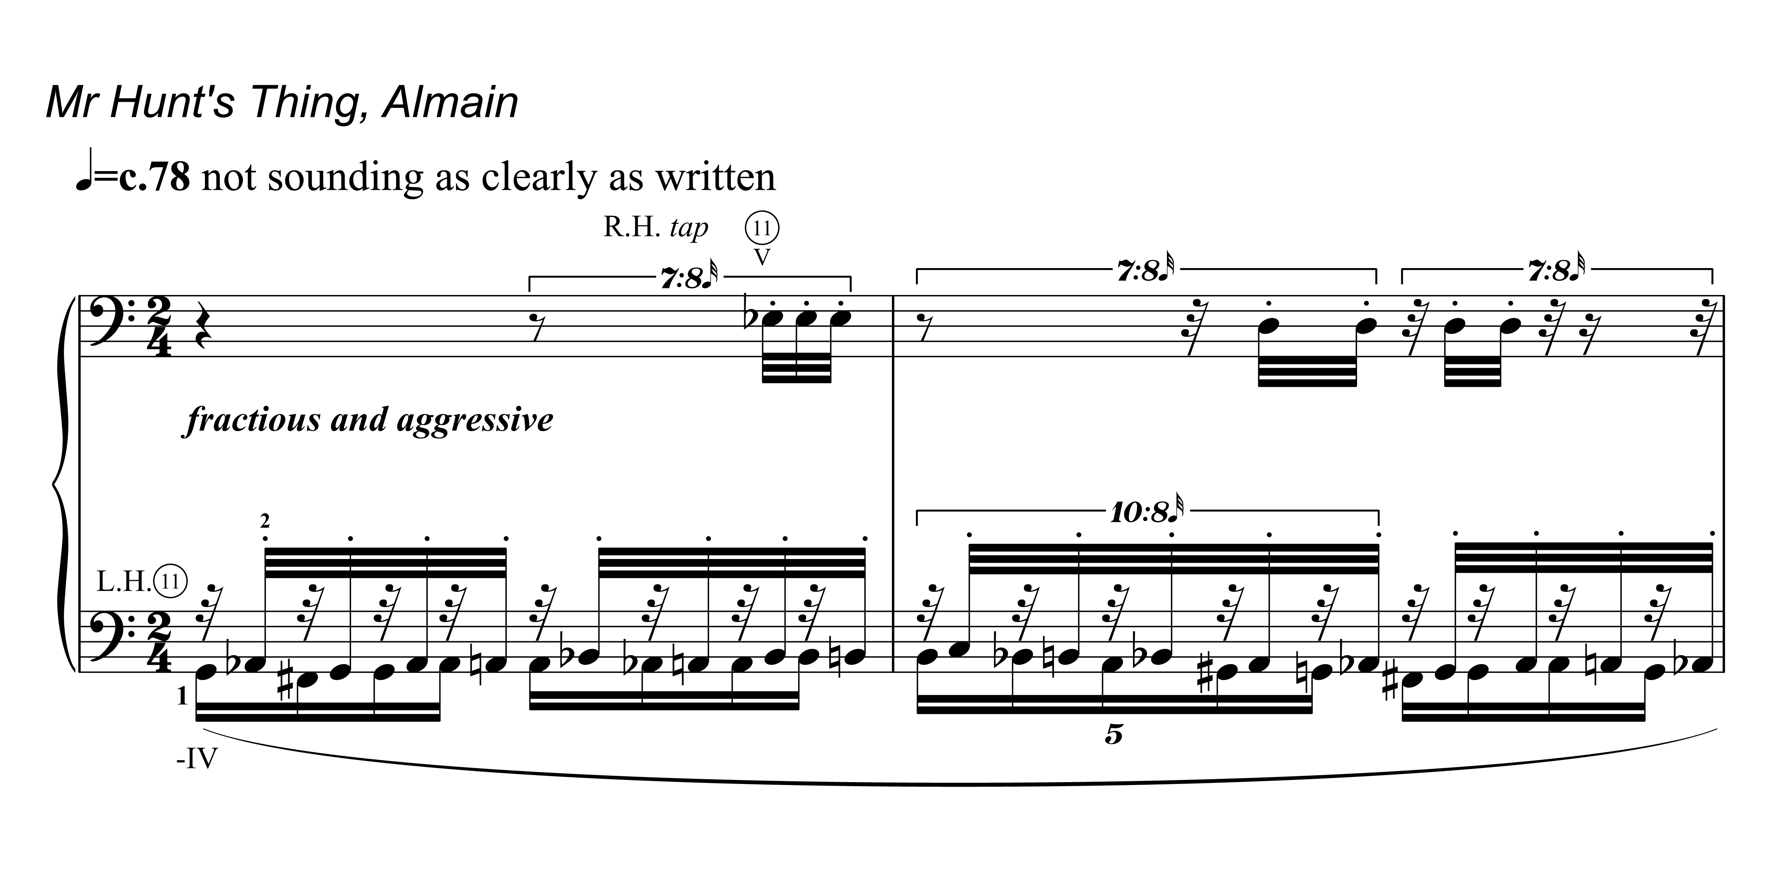

Like in the *Sonata for Solo Cello*, the large-scale choices made by the performer in *Forlorn Hope* require a strategy for the presentation of musical material throughout the piece, specifically in the dispersal of the Dowland references and their surrounding contexts.[24] While not specifically labelled as such, each of the dance sections has a moment of high intensity that may be calibrated in various ways with one another, and the numerous repetitions and developments of material throughout the sections can be articulated variously as echoes, or pre-echoes. As in a Choose Your Own Adventure story, the choices made by the performer/protagonist affect the outcome of the piece: most obviously in the order in which materials are heard, but also, significantly, in the ways in which perceived changes in *being* and *becoming* tendencies may be variously constituted in different performances, thus granting the manner of the piece’s structural and temporal unfolding to the control of the performer.

The voice of the composer can now be considered in relation to the notated score of *Forlorn Hope*. Like the previous diagram, Figure 4 reflects an understanding of subjectivity formation, but this time from the perspective of the composer. The thinking-through-listeningof a composer is different to that of a performer as described above, but a similar interplay is to be found. While a performer’s voice emerges essentially from the concrete listening of performing, and the live, bodily interaction with an instrument, a composer’s voice may rather emerge from the inner listening of the writing situation, through the identification of particular ways of shaping music, of solutions to musical problems that have a bearing on form and the physical nature of music as performed. A composer may interact with the concrete sounds of performance, through interaction with a performer in a rehearsal or recording situation, or indeed in a collaborative environment such as the Malmö sessions discussed above. But the composer’s voice emerges first and foremost from the solipsistic act of writing, and is expressed, as much as restrained, through a conception of instruments and notation.[25]

Where a performer interacts with the affordances and resistances of a musical instrument, so too a composer interacts with the affordances and resistances of notation. The writing of notation is guided and moderated by the composer’s own previous practice, and the compositional field in which they operate, and at one degree removed also by the broader notational practice associated with the specific instrument and performer. In the case of *Forlorn Hope* the notation of the existing Dowland material afforded many possibilities once transferred into the microtonal tuning system. But at the same time notational conventions provided resistance when it came to writing out the fluid glissing/tapping/trilling material that had been developed in the Malmö sessions. The opening bars of the *Almain* section (Figure 3) shows the meeting point of these two types of notational engagement; the undulating scalic shapes of the Dowland can be seen in the contours of the material, combined with a kind of tablature notation that indicates separate right and left hand movements. It is through this conception of notation that the voice of the composer emerges from the complex entanglement of Östersjö’s improvisations with Renaissance counterpoint.

The interaction with instruments is also multifaceted. While a composer will have a detailed, and on occasion innovative vision of the instrument they are writing for, access in a concrete sense is only gained through interaction with the performer, either through the notation itself or in person. It is important here to bear in mind the ontological difference between inner hearing and concrete listening[26]. Yet even at one degree removed, instruments provide affordances and resistances for the composer. By sheer virtue of the number of strings and relative lack of performance tradition, the eleven-string alto guitar affords multiple possibilities for novel tuning systems. But instrumental configuration provides limitations and resistances too. Some of these are discrete limitations, such as the impossibility of playing a note lower than the lowest string, but others are gradated: for example, it is impossible to move from one end of the fingerboard to the other instantly, but it is possible to execute that movement very fast, as long as the movement is situated within an enabling context. A compositional engagement with this kind of instrumental resistance can help to generate and refine materials. As Callis, Heyde, Kanga, and Sham observe, ‘a *creative* resistance takes hold of a potential obstruction and puts it to use’ (2015). It is through this kind of instrumental conception, and indeed through compositional imaginings of the body schema of the performer, that a composer’s voice can also emerge.

Figure 4. Subjectivity formation from the perspective of the composer.

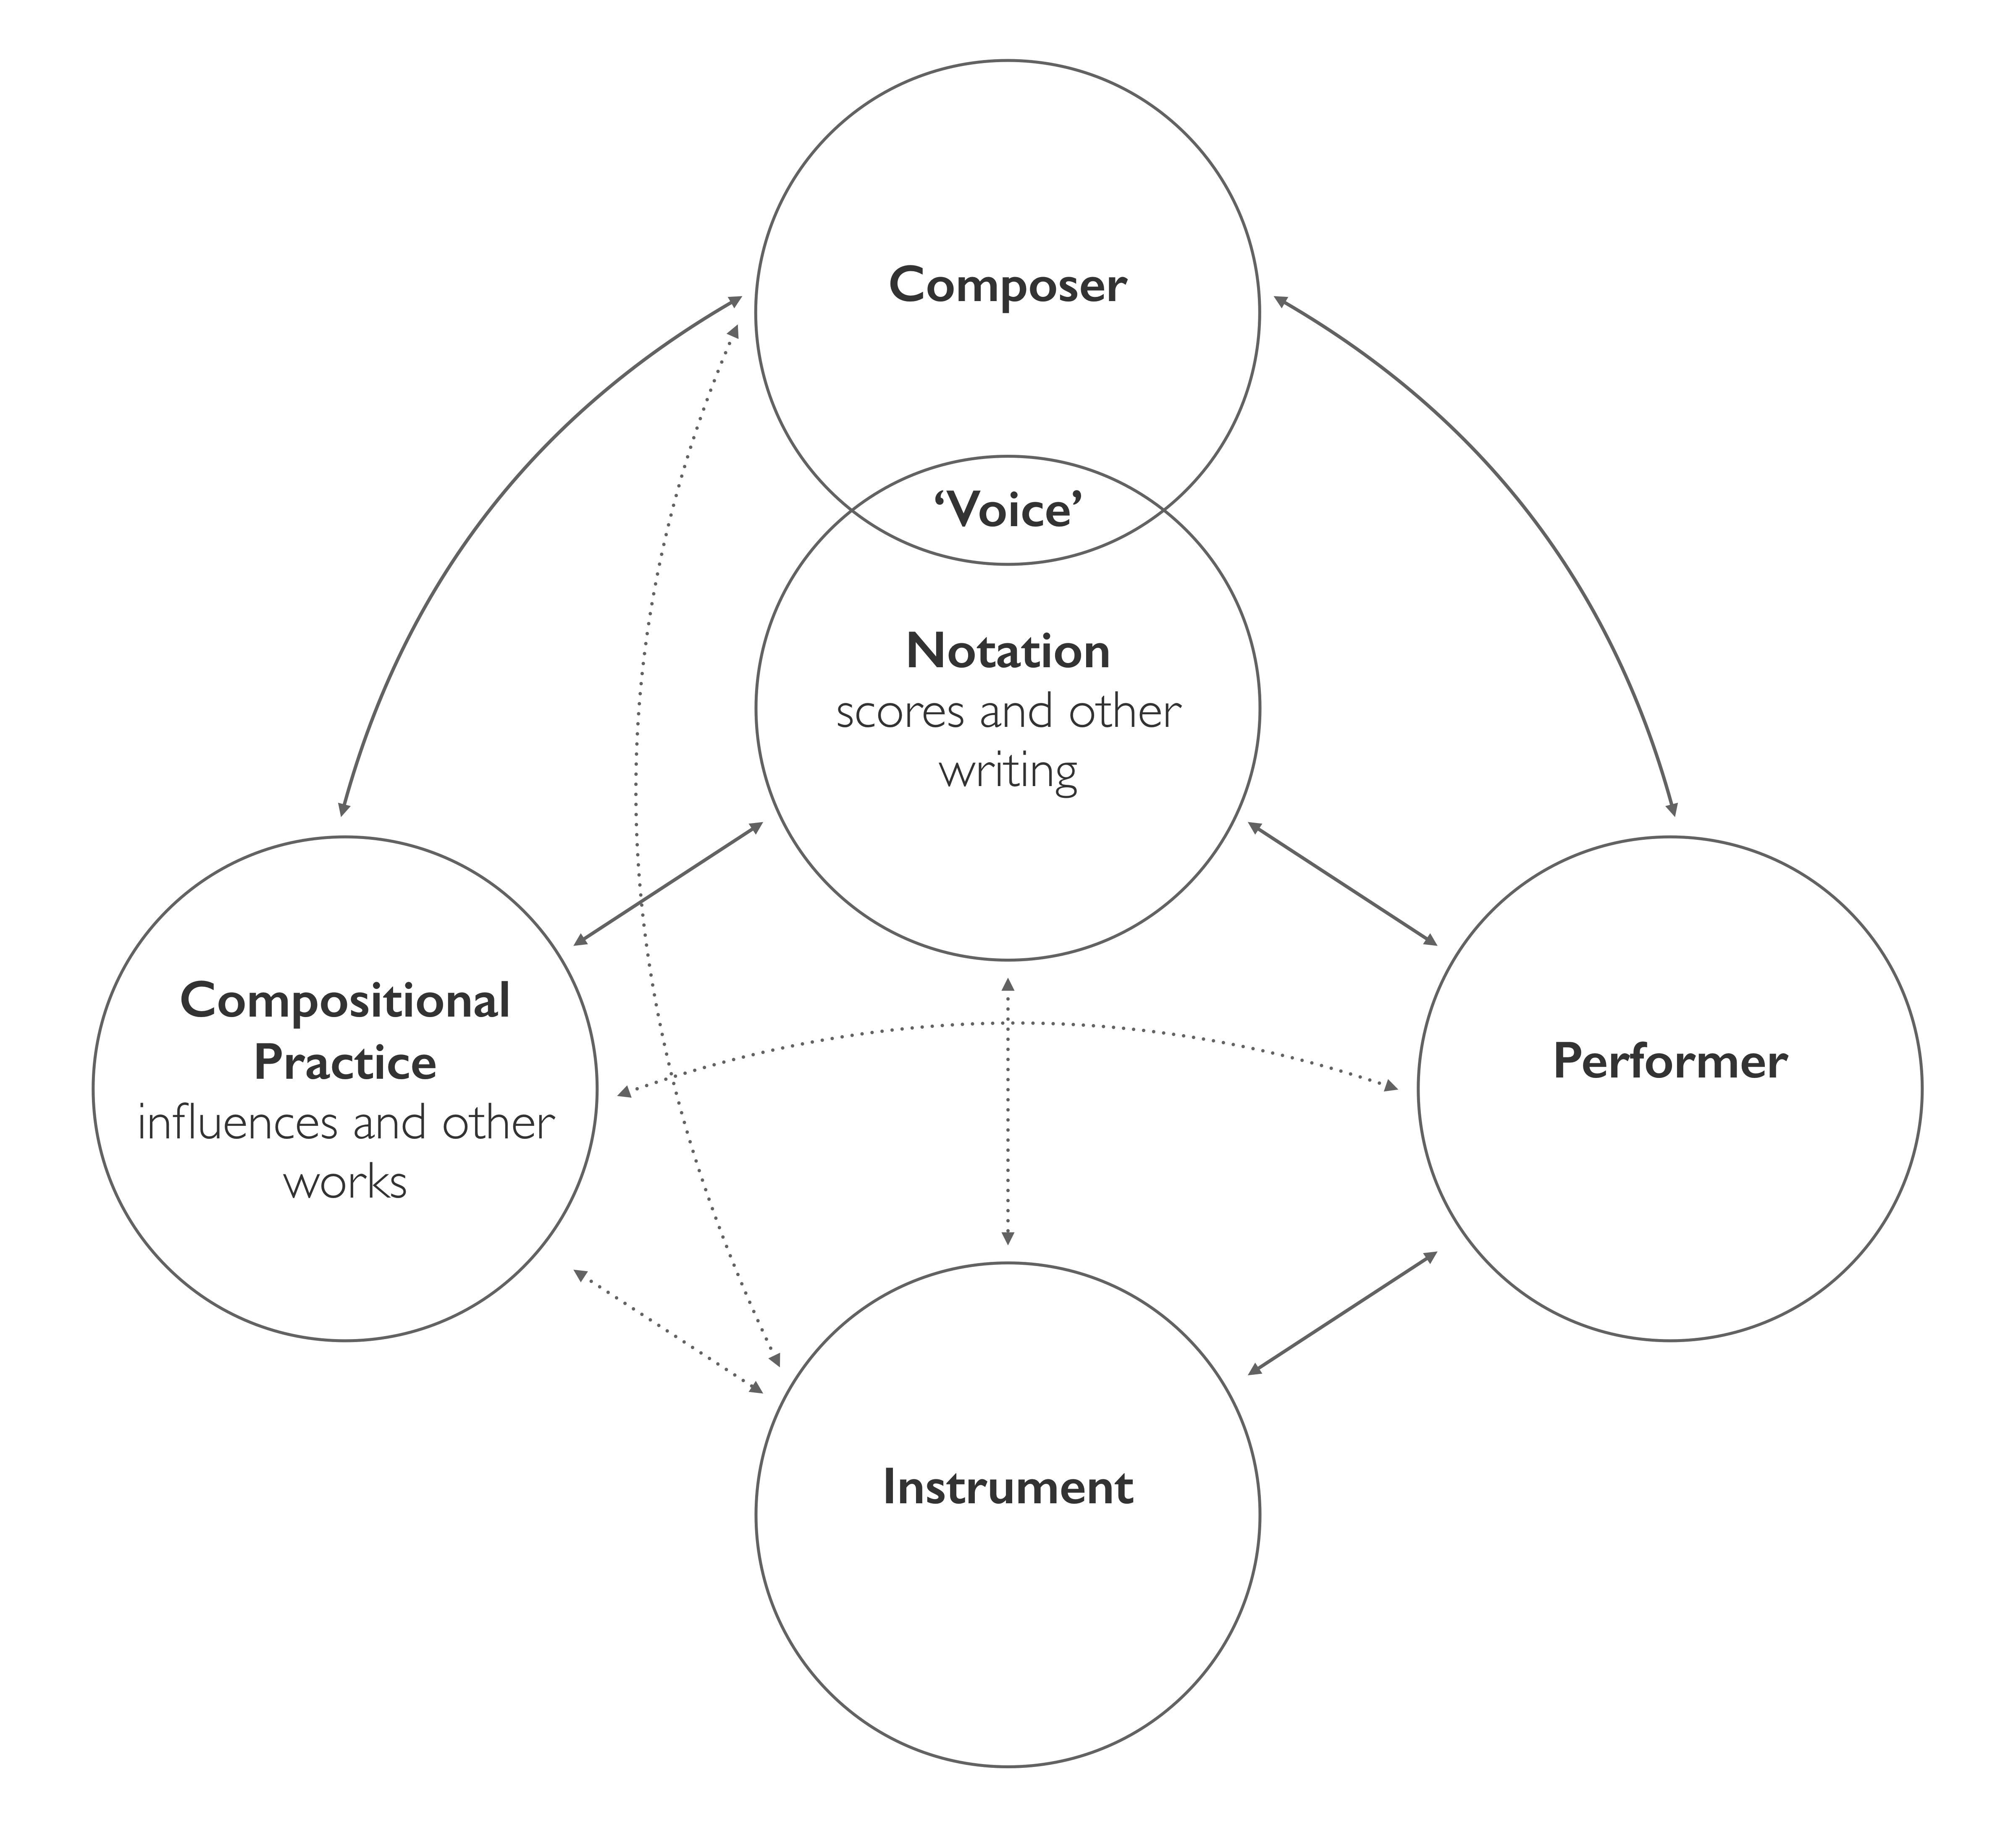

In *Forlorn Hope* the composer’s voice is heard first and foremost through the composed materials and the interaction with the borrowed Dowland. But there is a further voice that emerges out of the collaboration itself, the discursive voice of both composer and performer.[27] This is most obvious perhaps in the transferal of improvised proto-materials from the Malmö sessions into the score itself.[28] But also of importance is the malleable structure. The form of shared voice that is activated by the malleable structure is one where an understanding of musical delivery and nuance is renegotiated. Here, the performer is granted freedom in the large-scale expressive interpretation of material, in exchange for their engagement with a very specific and prescribed notion of structure. Once this has been established, the resultant collaborative dialogue is revisited and re-evaluated with each subsequent performance.

**Part 3: coping with austerity in *Austerity Measures I***

*Austerity Measures I* emerged from the bell-like qualities of the altered second tuning from the 2010 Malmö sessions. The tuning system was transferred to the 10-string guitar by simply removing the eleventh string, a pitch that both Gorton and Östersjö thought to be redundant. Figure 5 shows the tuning system used in *Austerity Measures I*; it functions in a similar manner to the system in *Forlorn Hope*, but with a different distribution of ‘flat’ and ‘sharp’ pitches across the instrument.

Figure 5. Tuning system for ten-string guitar in *Austerity Measures I.*

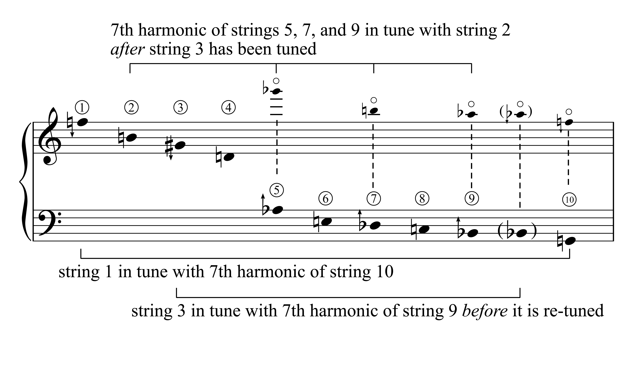

The score of *Austerity Measures I* consists of 64 bars of musical notation across two pages, with an additional set of instructions. The guitar player is instructed to label each bar with the number ‘1’, ‘2’, ‘3’, or ‘4’, with the first and last bars being labelled ‘4’. The numbers should frequently change order, but should be approximately equal in distribution throughout, and consecutive bars should not be labelled with the same number. The guitar player is encouraged to find a new solution for every performance. The score is to be played through four times; on the first time through all the bars should be played, as with most other pieces of music, but on each subsequent play-through an increasing number of the bars should be omitted, and replaced with rests. So on the second play-through only bars labelled ‘2’, ‘3’, and ‘4’ should be played, with the bars labelled ‘1’ being replaced with rests. On the third play-through only bars labelled ‘3’ and ‘4’ should be played, and on the final play-through only those bars labelled ‘4’ should be played. Thus by the fourth play-through only one quarter of the original material remains, with three quarters of the material having been cut and replaced with silence. The tempo of the piece is flexible in order to leave some space for the performer to phrase and shape the music in response to these austerity measures.[29]

Figure 6. The opening 12 bars of *Austerity Measures I* with one possible solution for labelling with numbers 1-4.

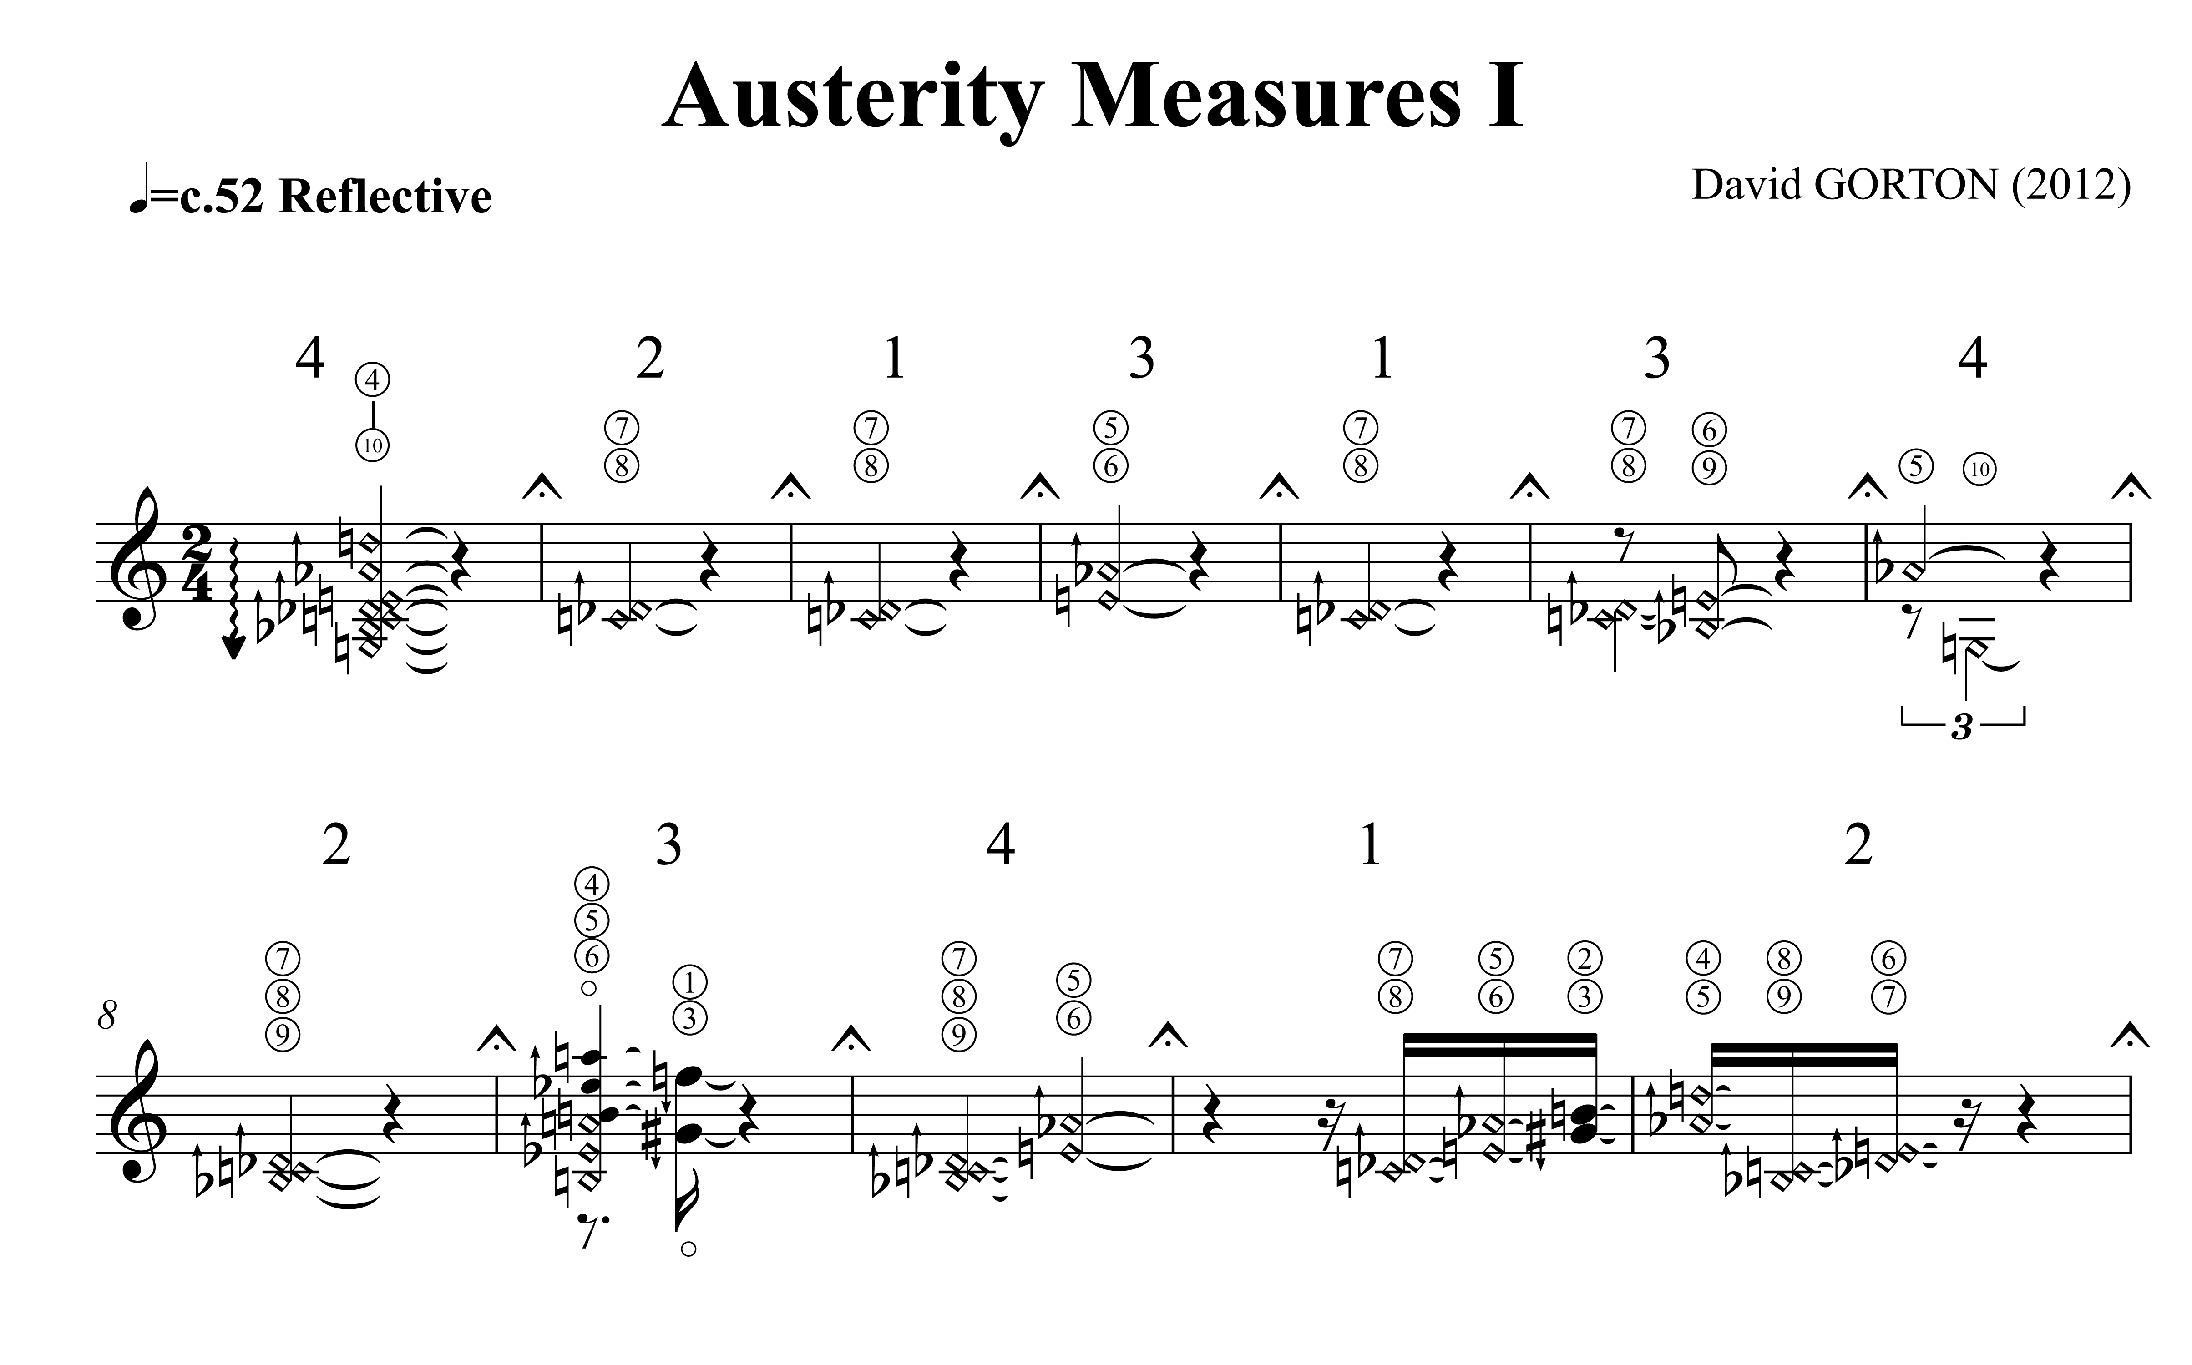

The score therefore lacks the kind of objective status that is often associated with musical notation, and the piece *Austerity Measures I* only comes into existence through its construction, and ultimately deconstruction, in performance, an action that is mediated through the encounter of the performer with the rudimentary economic system of the piece. This encounter is fundamentally improvisational, and over the course of the piece results in the aural effect of ‘finding’ the bell-like qualities of the tuning, as the resonance of the instrument becomes all that is left to fill the silences, echoing something of the character of the discoveries in the Malmö sessions.

The piece has a simple structure of five sections, which are marked by sudden changes in the material: first, an opening of chords and dyads; then bell-like semiquavers; then ascending arpeggios; then rapid broken chords; then a final ascending line. Each new repetition is signalled by the descending broken chord on harmonics in bar one. The cutting process is therefore heard in relation to this structure, and ultimately in relation to how the structure itself breaks down, as the amount of lost material results in the loss of structural integrity. This process can be seen in a phrasing analysis that was made as part of a broader analytical study undertaken with two researchers from the University of Ghent: Dirk Moelants and Esther Coorevits.[30] Four performances were analysed with the perceived phrasing structures negotiated among the two researchers, the composer, and the performer, and then annotated into new scores that indicated which bars had been cut at each play-through. In the early run-throughs in the performances it seems that new phrasing structures are articulated in response to the silent bars, but keeping the phrases within each of the five discrete sections. But by the final run-throughs there are not enough remaining bars to maintain this strategy, and new phrases are played that span across the boundaries of the sections. The study also draws on the analysis of video footage of the four performances, identifying and coding bodily movements made by Östersjö in each performance, specifically gestures that are not associated with sound production, such as movements of the head and shoulders. Preliminary results of this analysis show that as the new shapes of the music emerge through the cutting process, these new shapes are also expressed in the body movements of the performer. Both the shaping of the music in long lines, and the later fragments between long silences, are clearly projected and connected through the body movement.

The performance strategies used to manage the compositional process built into *Austerity Measures I* therefore draw heavily on the seeking of new phrase structures that link materials across increasing lengths of silence. But also, the gradual loss of material seems to be addressed through a series of expressive bodily gestures, often occurring at the beginning and ending of phrases. The main function of most of the coded gestures appears to be highlighting structurally significant moments, but gestures are also found that amplify musical events or even compensate for lacking resonance in long stretches. It is through these bodily gestures that the voice of the performer emerges in articulating and communicating the evolving musical structures. But the expressive gestures of the performer are associated with more than just the management of structure; they are hardwired into a compositional process that is re-enacted with each new performance. Thus, here, like in *Forlorn Hope*, emerges also the discursive voice of composer and performer.

The discursive voice can be conceived not simply as a combination of the composer’s and performer’s voices. In almost any performance one may discern an engagement between the voices of composer and performer. Rather, the discursive voice emerges from the process of collaboration. This is most obvious perhaps in pre-compositional collaborative work, such as the Malmö sessions. In situations like these the composer has direct access to the performer’s instrument, and the performer has direct access to the composer’s notation (at various stages of development), with the guiding and moderating performance and compositional practices shared. What emerges is a negotiation; a coming together of the two voices through the exploration of a situation in the present. Sawyer and DeZutter, in the context of improvised theatre, describe this generation of a shared creative product as ‘collaborative emergence,’ which they find to be ‘a defining characteristic of social encounters that are improvisational because only when the outcome is not scripted can there be unpredictability and contingency’ (2009).

It is argued above that the emergence of voice is largely at play on the subconscious level of the body schema and drawn to a large extent from the habitus of the musician. However, the observations regarding the discursive voice suggest that some of these processes may also be intentionally activated and take place on very different timescales. For instance, improvising musicians may develop a shared voice, a group sound, over very short periods of rehearsal. If we understand the initial working sessions in 2010 as ‘a situation in the present’, and materials in the composition as primordially linked to this context, it may be possible to conceive of any performance of *Austerity Measures I* also as an enactment of such a situation. A performance of *Austerity Measures I* activates the discursive voice of performer and composer in ways similar to how these voices were heard in the pre-compositional work. One may conclude then that in *Austerity Measures I*, musical gesture and the surplus of meaning that it affords, is more central to the identity of the piece than the letter of the writing. What the composition ultimately seems to achieve is to activate the same collaborative mode of operation as was driving the work already in the first working sessions.

This is equally true of the malleable structures in all of the pieces discussed above. The compositions create the conditions for the discursive voice to be continued into performance, and renewed afresh in each new performance, linking together the pre- and post-compositional phases. This observation may appear to counter the argument put forward by Sawyer and DeZutter that improvisation would be a defining factor in ‘collaborative emergence’, since here, a script is activated in ways that appear to allow for a discursive voice to emerge. However, rather than providing a counter argument, perhaps Sawyer and DeZutter instead may suggest that performance and composition are both facets of musical improvisation. Following Tim Ingold we find that artistic creation has common features that suggest that the practices of composers and performers may be more aligned than is generally thought. The act of writing implies a weaving of material, where the signs on the paper lead just as much as they are led by the author:

And so drawing carries on, dicing with the hazards of improvisation, tracing a path that runs not from an image in the mind of a maker to its expression in the material world but orthogonally, looping in and out between mind and paper rather as a swimmer dives into water and comes back up for air or as the embroiderer’s thread loops over and under in stitching (Ingold, 2010, p. 100).

This image contains echoes of the discussion on notation and ‘structure’ above. It can be argued too that this is how any performance unfolds in constant consideration of how the music just played must be woven into its continuation.

Bruce Ellis Benson (2003) takes this line of thought further, arguing for a participatory perspective on the ontology of musical works, suggesting that work identity is not specified by the score only but emerges in the interaction between listener, performer and composer. Along similar lines to Ingold’s image of weaving, Benson suggests that composing and performing are in essence different modes of musical improvisation. Composer, performer, and listener interact with a musical work in a larger musical practice, a space within which the music can unfold in time and within which musical meaning can be created.

If we say (modifying Heidegger) that a piece of music opens up a world, it should be clear that this ‘world’ of the piece of music is one that is not self-contained. Rather, it is a world within a world, a musical space that is created *within* and *out of* a larger musical practice. Moreover, just as the world of Dasein is not a *physical* world but a world of activity, so the piece of music is likewise a world of activity. It is a ‘space’ that is both created by and allows for musical activity. But what does it mean for a performer to exist within this space? Of course, in one sense, the answer is obvious. If composers improvise their pieces amid the activity of music making, then performers are *already there* (Benson, 2003, p. 148).

Benson argues that the nature of being in this space is that of improvisation. The nature of improvisation in any performance of *Forlorn Hope* or *Austerity Measures I* then has to do, not with creating variations on the pitch material, but in the temporal shaping, the grouping of bars in larger phrases or the management of the sections. In the weaving of musical material, it is not anymore the signs in the score that ‘lead just as much as they are led’ but it is in the continuous unfolding of sounding musical matter that the performer is drawn ‘looping in and out between mind and paper rather as a swimmer dives into water and comes back’ (Ingold, 2010, p. 100).

Ultimately, the discursive voice of composer and performer is the heart of an expression of subjectivity in musical collaboration. It emerges from embodied interactions with musical materials, traditions, and between people, at levels that are largely beyond the verbal domain, carried out in thinking-through-listening. While both *Forlorn Hope* and *Austerity Measures I* are conceptually conceived statements on contemporary cultural politics, they simultaneously invite musicians into the improvisatory practices of listening to and creating music, no matter the degree of destructive ignorance that currently defines the political state of affairs.

**Acknowledgements**

The authors are grateful to the following: Catherine Laws, principal investigator of the Performance, Subjectivity and Experimentation research cluster at the Orpheus Institute, Ghent, of which this study is a part; Dirk Moelants and Esther Coorevits at the Institute for Psychoacoustics and Electronic Music, University of Ghent; Eric Clarke and Mark Doffman, and the Creative Practice in Contemporary Concert Music Project, University of Oxford, part of the AHRC Research Centre for Musical Performance as Creative Practice.

**Biographical notes**

David Gorton is a British composer interested in microtonal tuning systems and performer virtuosity. A winner of the Royal Philharmonic Society Composition Prize he has worked with ensembles that include the BBC Symphony Orchestra, London Sinfonietta, Ensemble Exposé, CHROMA, and the Kreutzer Quartet. Much of his recent music is recorded on the Métier label. He is Associate Professor of Music at the Royal Academy of Music, University of London.

Stefan Östersjö is a leading classical guitarist. Since his debut CD (Swedish Grammy in 1997) he has recorded extensively and toured Europe, the US and Asia. His special fields of interest are interaction with electronics, experiments with stringed instruments other than the classical guitar and collaborative practices, also between different cultures. As a soloist he has cooperated with conductors such as Lothar Zagrosek, Peter Eötvös, Pierre André Valade, Mario Venzago, Franck Ollu and Andrew Manze. He is Associate Professor at the Malmö Academy of Music.

**References**

Barsalou, L. W. (2008). Grounded cognition. *Annu. Rev. Psychol*., 59, 617-645. doi: 10.1146/annurev.psych.59.103006.093639.

Bayley, A. (2010). Multiple takes: using recordings to document creative process. In A. Bayley (Ed.), *Recorded music: performance, culture and technology* (pp. 206-224)*.* Cambridge: Cambridge University Press.

Benson, B. E. (2003). *The improvisation of musical dialogue: a phenomenology of music*. Cambridge: Cambridge University Press.

Brown, J. S., Collins, A., & Duguid, P. (1989). Situated cognition and the culture of learning. *Educational researcher*, 18(1), 32-42. doi: 10.3102/0013189X018001032.

Callis, S., Heyde, N., Kanga, Z., & Sham, O. (2015). Creative resistance as a performance tool. *Music & Practice*, 2. Retreived from http://www.musicandpractice.org/volume-2/

Clarke, E., Doffman, M., Gorton, D., & Östersjö, S. (Forthcoming). Fluid practices, solid roles? The evolution of *Forlorn Hope*. In E. Clarke & M. Doffman (Eds.), *Creativity, Improvisation and Collaboration: Perspectives on the Performance of Contemporary Music*. Oxford: Oxford University Press.

Clarke, E., Doffman, M., & Lim, L. (2013). Distributed creativity and ecological dynamics: a case study of Liza Lim’s ‘Tongue of the Invisible’. *Music & Letters*, 94(4), 628-663. doi: 10.1093/ml/gct118.

Coessens, K. & Östersjö, S. (2014). Habitus and the Resistance of Culture.In D. Crispin & B. Gilmore (Eds.). *Artistic experimentation in music: an anthology* (pp. 333-348). Leuven: Leuven University Press.

Coessens, K., Frisk, H., & Östersjö, S. (2014). Repetition, Resonance, and Discernment. In D. Crispin & B. Gilmore (Eds.). *Artistic experimentation in music: an anthology* (pp. 349-364). Leuven: Leuven University Press.

Coorevits, E., Moelants, D., Östersjö, S., Gorton, D, & Leman, M. (2016). Decomposing a composition: on the multi-layered analysis of expressive music performance. In M. Aramaki, R. Kronland-Martinet, & S. Ystad (Eds.). *Music, Mind, and Embodiment* (pp. 167-189). Cham: Springer International Publishing.

Croft, J. (2015). Composition is not research. *Tempo*, 69, 6-11. doi: 10.1017/S0040298214000989.

Cumming, N. (2001). *The sonic self: musical subjectivity and signification*. Bloomington and Indianapolis, IN: Indiana University Press.

De Preester, H. (2007). To perform the layered body - a short exploration of the body in performance. *Janus Head*, 9(2), 349-383.

Desmet, F., Nijs, L., Demey, M., Lesaffre, M., Martens, J.P., & Leman, M. (2012). Assessing a clarinet player’s performer gestures in relation to locally intended musical targets. *Journal of New Music Research*,41(1), 31-48. doi: 10.1080/09298215.2011.649769.

Fitch, F. & Heyde, N. (2007). ‘Recercar’ – the collaborative process as invention. *twentieth-century music*, 4, 71-95. doi:10.1017/S1478572207000539.

Fraser, J. T. (1982). *The genesis and evolution of time: a critique of interpretations in physics*. Amherst, MA: University of Massachusetts Press.

Fraser, J. T. (1990). *Of time passion, and knowledge: reflections on the strategy of existence* (2nd ed.). Princeton, NJ: Princeton University Press.

Gallagher, S. & Cole, J. (1995). Body image and body schema in a deafferented subject. *Journal of Mind and Behavior*, 16(4), 369-390.

Godøy, R. I. (2006). Gestural-sonorous objects: embodied extensions of Schaeffer's conceptual apparatus. *Organised sound,* 11(2), 149-157. doi: 10.1017/S1355771806001439.

Henbing, L. & Leman, M. ([2007](https://biblio.ugent.be/publication?q=year+exact+2007)). A gesture-based typology of sliding-tones in guqin music. *Journal of New Music Research*, 36(2), 61-82. doi: 10.1080/09298210701755073.

Ingold, T. (2010). The textility of making. *Cambridge Journal of Economics*, 34, 91-102. doi: 10.1093/cje/bep042

John-Steiner, V. (2006). *Creative collaboration*. Oxford: Oxford University Press.

Lachenmann, H. (1996). *Musik als existentielle Erfahrung* [Music as an existential experience] (J. Häusler, Ed.). Wiesbaden: Breitkopf & Härtel/Insel.

Leman, M. (2008). *Embodied music cognition and mediation technology*, Cambridge, MA: MIT Press.

Livingstone, S. R., & Thompson, W. F. (2006). Multimodal affective interaction: a comment on musical origins. *Music Perception*,24(1), 89-94. doi: 10.1525/mp.2006.24.1.89.

Marratto, S. L. (2012). *The intercorporeal self: Merleau-Ponty on subjectivity*. Albany, NY: SUNY Press.

Merleau-Ponty, M. (2002). *Phenomenology of perception* (C. Smith, Trans.). London and New York: Routledge.

Östersjö, S. (2008). *SHUT UP 'N' PLAY! Negotiating the musical work.* PhD thesis. Malmö: Lund University.

Östersjö, S. (2012). The resistance of the Turkish Makam and the habitus of a performer. *Contemporary Music Review*, 32(2)**,** 201-213. doi: 10.1080/07494467.2013.775812.

Sawyer R. K., & DeZutter, S. (2009). Distributed creativity: how collective creations emerge from collaboration. *Psychology of Aesthetics, Creativity, and the Arts*, 3(2), 81-92. doi: 10.1037/a0013282.

Taylor, A. (Forthcoming). 'Collaboration' in contemporary music: a theoretical view. *Contemporary Music Review*.

Thompson, W. F., Graham, P., & Russo, F. A. (2005). Seeing music performance: visual influences on perception and experience. *Semiotica,* 156(1), 177–201. doi: 10.1515/semi.2005.2005.156.203.

Varela, F. J., Thompson, E., & Rosch, E. (1991). *The embodied mind: cognitive science and human experience*. Cambridge, MA: MIT Press.

1. That is, contemporary classical art music, and other fields of music making that those trained in the former may branch into. In other genres, collaboration between musicians is a given and is normally not much discussed. Although, the academic study of collaboration has now also moved into contemporary jazz and non-western music.
2. For attempts at more nuanced definitions see John-Steiner (2006), Östersjö (2008), and Taylor (forthcoming).
3. Fitch and Heyde (2007) cite examples of Brahms–Joachim, Elgar–Kreisler, and Chopin–Franchomme manuscripts as evidence of collaboration, even if the process itself remains inaccessible.
4. The very existence of this journal edition is evidence of this interest.
5. More advanced computer skills, such as html coding, have to wait until year 4.
6. John Croft’s article ‘Composition is not research’ caused rather a stir when it was published. Whether you agree with its arguments or not, the article is useful in laying out the scope of the battleground (Croft, 2015).
7. See for example Stefan Östersjö’s work with composer Henrik Frisk on *Repetition Repeats all other Repetitions* (Coessens, Frisk, and Östersjö, 2014).
8. Both pieces were composed by David Gorton for, and with, Stefan Östersjö as part of an on-going collaboration. *Forlorn Hope* was first performed by Stefan Östersjö and Juan Parra Cancino (electronics), ORCiM Research Festival, Orpheus Institute, Ghent, 5 October 2012. A version without electronics is recorded by Stefan Östersjö on *David Gorton: Pavans and Galliards – Variations on John Dowland* (forthcoming). *Austerity Measures I* was first performed by Stefan Östersjö, ORCiM Research Festival, Orpheus Institute, Ghent, 2 October 2014. Two versions have been recorded for future release. *Austerity Measures I is* the first in an on-going series of similarly titled pieces.
9. Clarke et al. (2013) comment on the potential problems and benefits of recording rehearsals on video. Both Gorton and Östersjö were used to working with a camera in the room.
10. Gorton has run a practical class about composer-performer collaboration at the Royal Academy of Music for the past decade. Almost all of the student collaborations begin with this kind of demonstrative interaction, what Fitch and Heyde describe as a ‘performer giving the composer access to his “box of tricks”’ (2007, p. 73).
11. The duration of playing time was calculated with reference to the video footage of the sessions.
12. Examples from the video documentation can be found in the online material accompanying Clarke, Doffman, Gorton, and Österjsö (forthcoming). There are also additional extracts from the videos available online.
13. Further discussion of these three methods and other kinds of interaction between composer and performer in the Malmö sessions can be found in Clarke et al. (forthcoming).
14. This is of course an oversimplification, but Östersjö is a classically trained guitarist who has specialised in contemporary classical music performance. As a performer he has established long-term collaborative projects with a number of composers across the world. But he is also active in the field of free improvisation and has a strong presence on the South East Asian music scene through extensive cross-cultural work. Hence, a number of different musical traditions are embodied by the same musician in this situation.
15. Choose Your Own Adventure books were a popular series of children’s books originally published from the end of the 1970s through to the 1990s. The Choose Your Own Adventure website (www.cyoa.com) describes them thus: ‘Each story is written from a second-person point of view, with the reader assuming the role of the protagonist and making choices that determine the main character’s actions in response to the plot and its outcome.’
16. Fraser recognises the differences between time as understood by classical physics, quantum mechanics, and human experience, by identifying a number of inclusive yet distinct evolutionary temporalities. The level of human temporality achieves uniqueness through its triadic form of past-present-future, as opposed to the diodic before/after of preceding levels.
17. Any evaluation of music described in terms of experiential temporality must take into account its own subjectivity. The ways in which music affects a listener are dependent on personal experience and must be set within the context of an individual listener who is influenced by personal experience, pre-knowledge of a work or genre, and an ability and inclination to listen.
18. In tonal music the dominant characteristic in the formation of this kind of structure is the functional harmonic syntax itself, and it need hardly be stated that the evaluation of structure in terms of harmonic stability and instability, themselves a being/becoming pair, is common currency.
19. The compositional work from 2004-2006 was supported by a Leverhulme Trust Early Career Fellowship.
20. See for example *Sonnentode* for soprano and ensemble (2005), *Erinnerungsspiel* for oboe and optional electronics (2006), *2nd Sonata for Cello* (2007), and *Schmetterlingsspiel* for oboe and ensemble (2013).
21. See for example *String Quartet: Trajectories* (2006) and *Melting Forms* for piano trio (2005).
22. *Sonata for Solo Cello* was first performed by Neil Heyde at the Tate Gallery, St Ives, 11 September 2005. Two versions of it are recorded by Neil Heyde on *Trajectories: Music by David Gorton* (Métier, 2010).
23. Following Dowland’s example the dance sections are named after prominent, although not necessarily popular, members of public life.
24. An additional layer of complexity is added when the piece is performed with electronics. The preparation of the electronics part with Juan Parra Cancino for the first performance in 2012 was itself a collaborative activity, not dissimilar in character to the 2010 Malmö sessions.
25. This model is assuming a composer who is not simultaneously a performer.
26. While inner hearing draws on analytical thinking and inner imagination, concrete listening emerges from the ecological system of human perception. (For a further discussion see Östersjö, 2008, pp. 79-80).
27. This concept will be explored further below.
28. See Clarke et al. (forthcoming) for details of this transferal process.
29. There is also a version of the piece in which the score is played through three times; here the score is marked up with the numbers 1-3 rather than 1-4.
30. The on-going study of four performances of *Austerity Measures I* given by Östersjö at the 2014 Orpheus Research Festival draws on quantitative timing and movement data and qualitative analysis of audio and video. Preliminary method development and results are published in Coorevits et al. (2016).